SUBCOURSE EDITION
IT0843 B

US ARMY INTELLIGENCE CENTER

COUNTERMEASURES

DEVELOPMENT

Risk Assessment Matrix

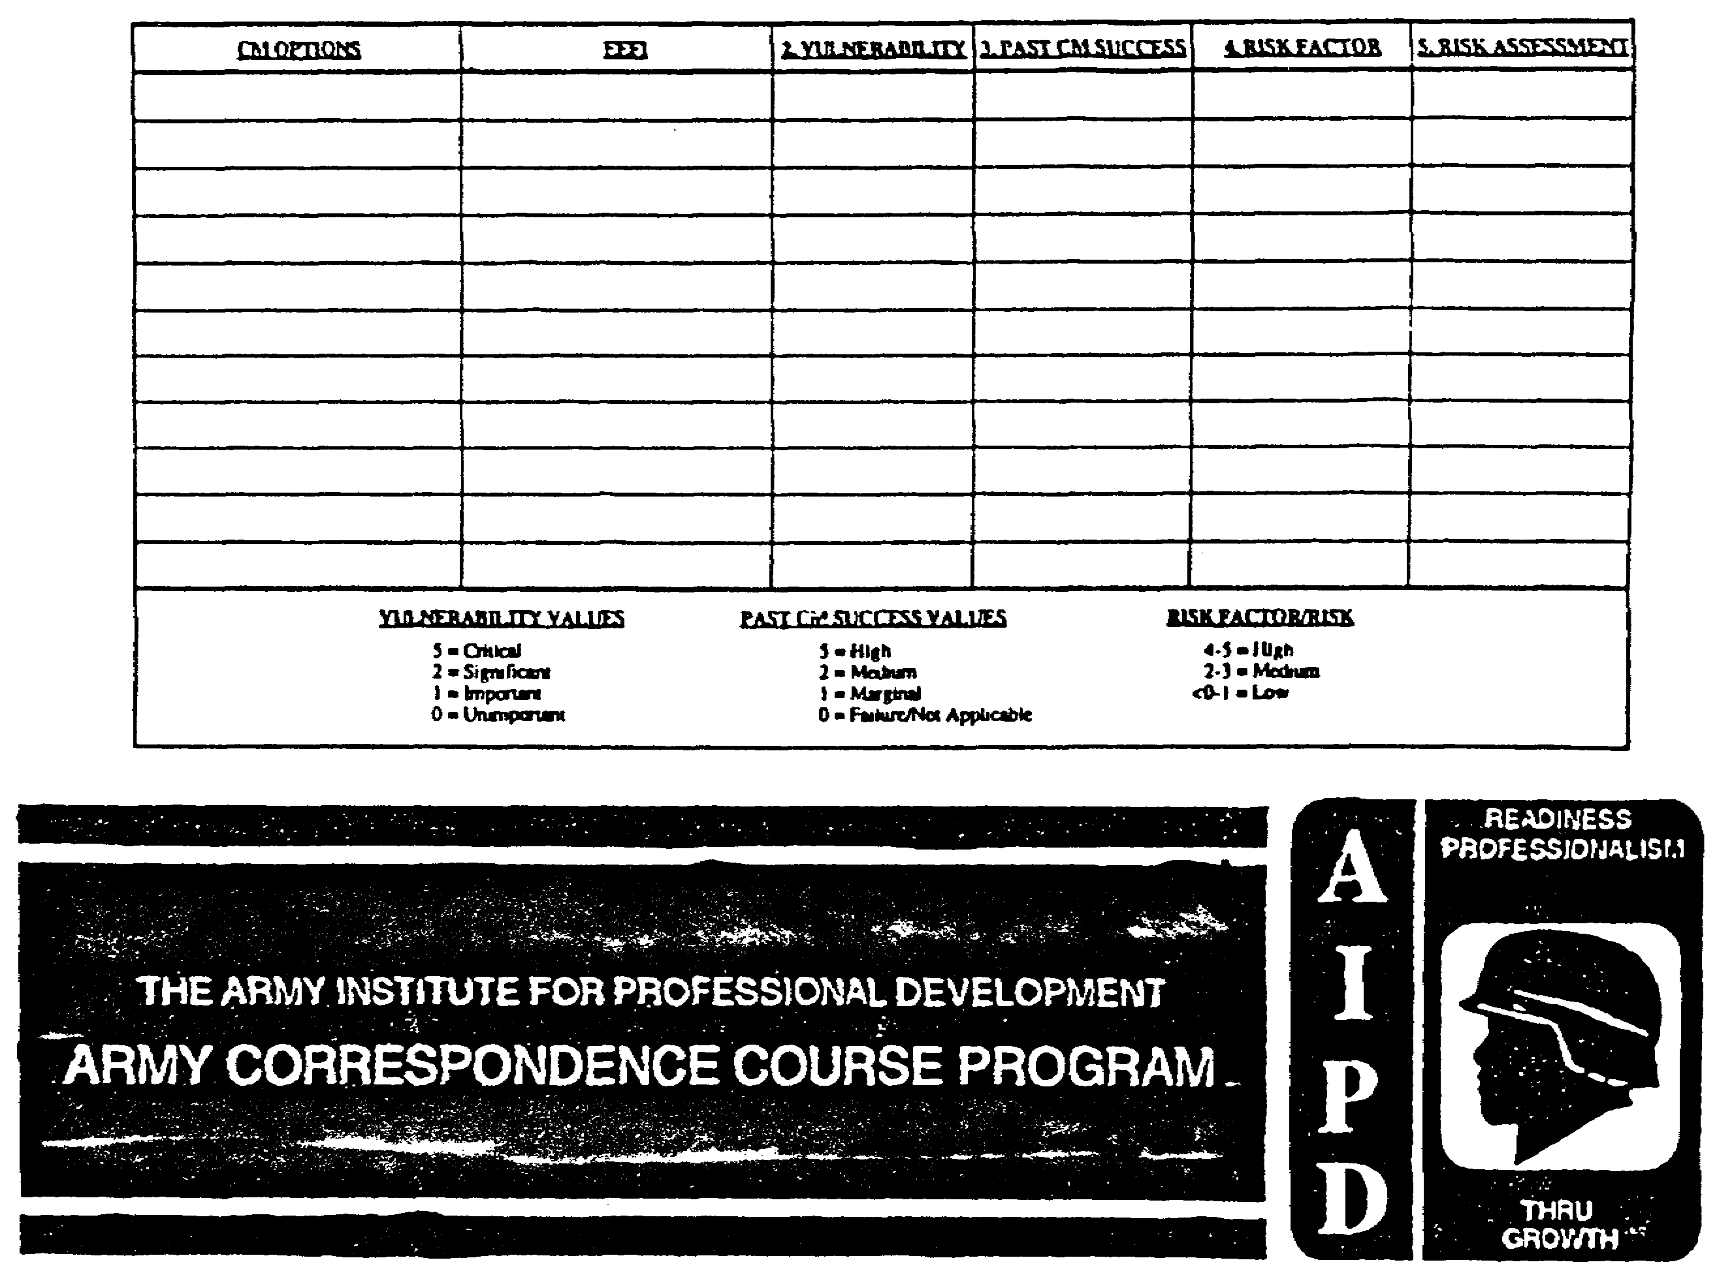

COUNTERMEASURES DEVELOPMENT

Subcourse Number IT0843

Edition B

United States Army Intelligence Center

Fort Huachuca, Arizona 85613-6000

3 Credit Hours

Edition Date: April 1996

SUBCOURSE OVERVIEW

This subcourse teaches basic procedures which must be implemented in order to develop countermeasures (CM). This subcourse contains six lessons which are directly related to the six steps in the countermeasures development process. Countermeasures development is the third of the four-step cyclic Counter-Signals Intelligence (C-SIGINT) process.

Non-MOS 97G personnel should complete USAICS subcourses IT 0841 and IT 0842 prior to taking this subcourse.

This subcourse reflects current doctrine at time of preparation. In your own work situation, always refer to the latest publications.

The words he, "him" "his" and "men," when used in this publication, represent the masculine and feminine genders unless otherwise stated.

TERMINAL LEARNING OBJECTIVE

ACTION: To identify procedures for CM options identification, relative benefit analysis, risk assessment, risk to benefit comparison, development of prioritized CM options list and production of output.

CONDITIONS Access to Field Manual (FM) 34-60, Appendix A; FM 101-5, Appendices C and E; and local standing operating procedures (SOP).

STANDARDS: To know basic implementation procedures to develop CM.

i IT0843

TABLE OF CONTENTS

Section Page

Subcourse Overview i

Lesson 1: Identify Countermeasures Options 1-1
Practice Exercise 1-7
Answer Key and Feedback 1-8

Lesson 2: Conduct Relative Benefit Analysis 2-1
Practice Exercise 2-12
Answer Key and Feedback 2-14

Lesson 3: Conduct Risk Assessment 3-1
Practice Exercise 3-4
Answer Key and Feedback 3-6

Lesson 4: Conduct Comparison of Benefit to Risk 4-1
Practice Exercise 4-4
Answer Key and Feedback 4-6

Lesson 5: Develop Prioritized Countermeasures Options List 5-1
Practice Exercise 5-5
Answer Key and Feedback 5-7

Lesson 6: Produce Output 6-1
Practice Exercise 6-4
Answer Key and Feedback 6-6

GLOSSARY A-1

IT0843 ii

LESSON 1

IDENTIFY COUNTERMEASURES OPTIONS

CRITICAL TASK: 301-351-1601

OVERVIEW

TASK DESCRIPTION

In this lesson you will learn to identify countermeasure (CM) options.

LEARNING OBJECTIVE:

ACTIONS: Describe the information and procedures required to identify CM options.

CONDITION: To correctly prepare CM options.

STANDARD: To correctly identify CM options.

REFERENCE: The material contained in this lesson was derived from the following publication: FM 34-60

INTRODUCTION

Countermeasures options provide the commander a secure alternative means of exercising command and control (C2) during Communications-electronics (C-E) operations. This lesson's objective is to determine available CM options to support the commander's operational concepts and objectives. CM options identification provides the commander with information to support his decisions about resource allocation to overcome or limit vulnerabilities affecting his operational objectives. There are two sub-tasks:

- Collect data.

- Determine CM options for each vulnerability.

Review Data Sources

The Multidiscipline Counterintelligence (MDCI) analyst must first review the vulnerability assessment and list identified vulnerabilities on the CM options worksheet (Figure 1-1). After listing vulnerabilities (Figure 1-2), he must access the MDCI and command CM data bases and extract data on previously used CM for the vulnerabilities which resulted from the assessment. He must enter the applicable CM on the CM options worksheet (Figure 1-3) The next procedure is to review the current situation and commander's decision.

It is important to ensure data gathered, and regarding the situation, is current. It is also important to ensure information retained regarding the commander's decision is accurate. Commanders differ widely in personality, and this affects the manner in which they will apply CM options (for example, one commander may enforce strict emissions control while another may require

1-1 IT0843

continuous C-E operations, to accomplish similar missions). Now that the necessary data is collected, the MDCI analyst is ready to continue with CM options development.

Identify CM Options for Each Vulnerability.

The MDCI analyst must first prepare a vulnerability to CM Matrix (Figure 1-4) using information obtained from the CM options worksheet (Figure 1-3). He completes the matrix by listing identified vulnerabilities in the vertical column on the left, while placing CM options in the horizontal column at the top. He then matches a vulnerability to a CM option. This match is determined by using data obtained from sources used during the data collection sub-task to identify CM that were used in the past for given vulnerabilities. He must check the blocks common to the vulnerability and CM option.

IDENTIFY
CM
ANALYZE
RELATIVE
BENEFIT
ASSESS
RISK
COMPARE
RISK TO
BENEFIT
DEVELOP
PRIORITIZED
CM OPTIONS
LIST
PRODUCE
OUTPUT

IT0843 1-2

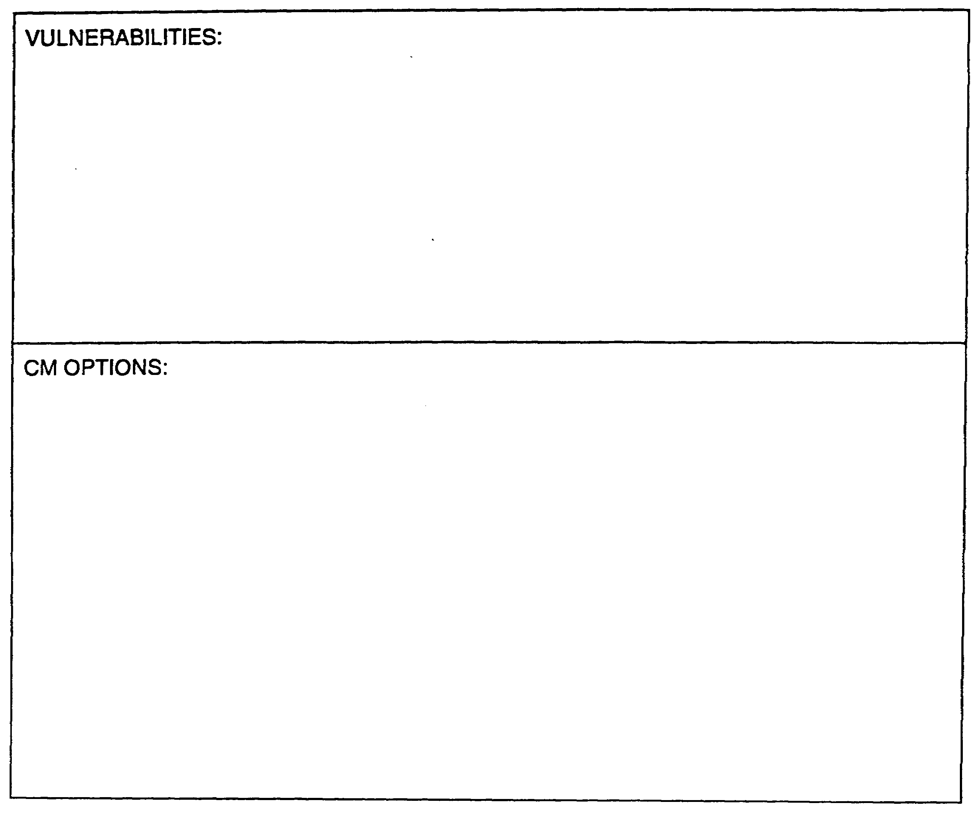

Figure 1-1. Countermeasures Options Worksheet (Blank).

1-3 IT0843

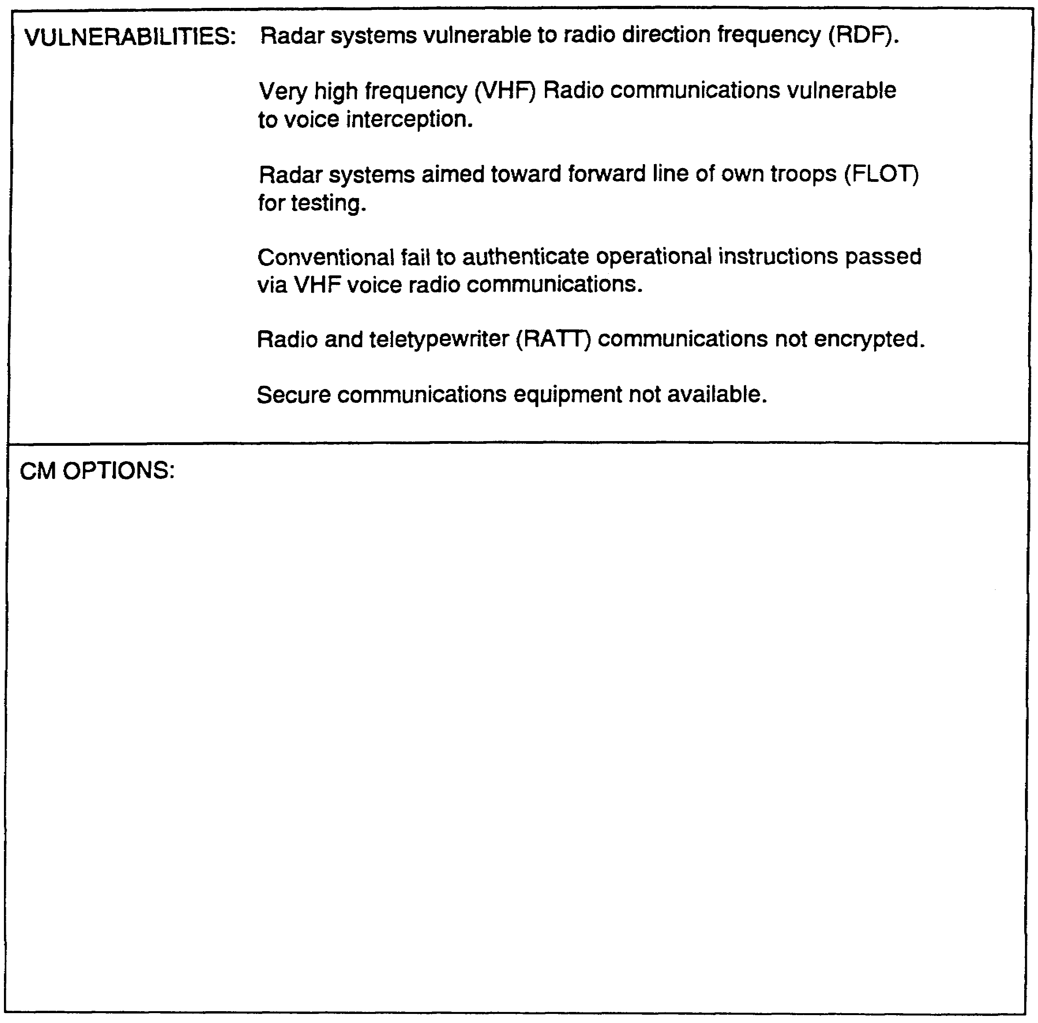

Figure 1-2. Countermeasures Options Worksheet (Vulnerabilities).

IT0843 1-4

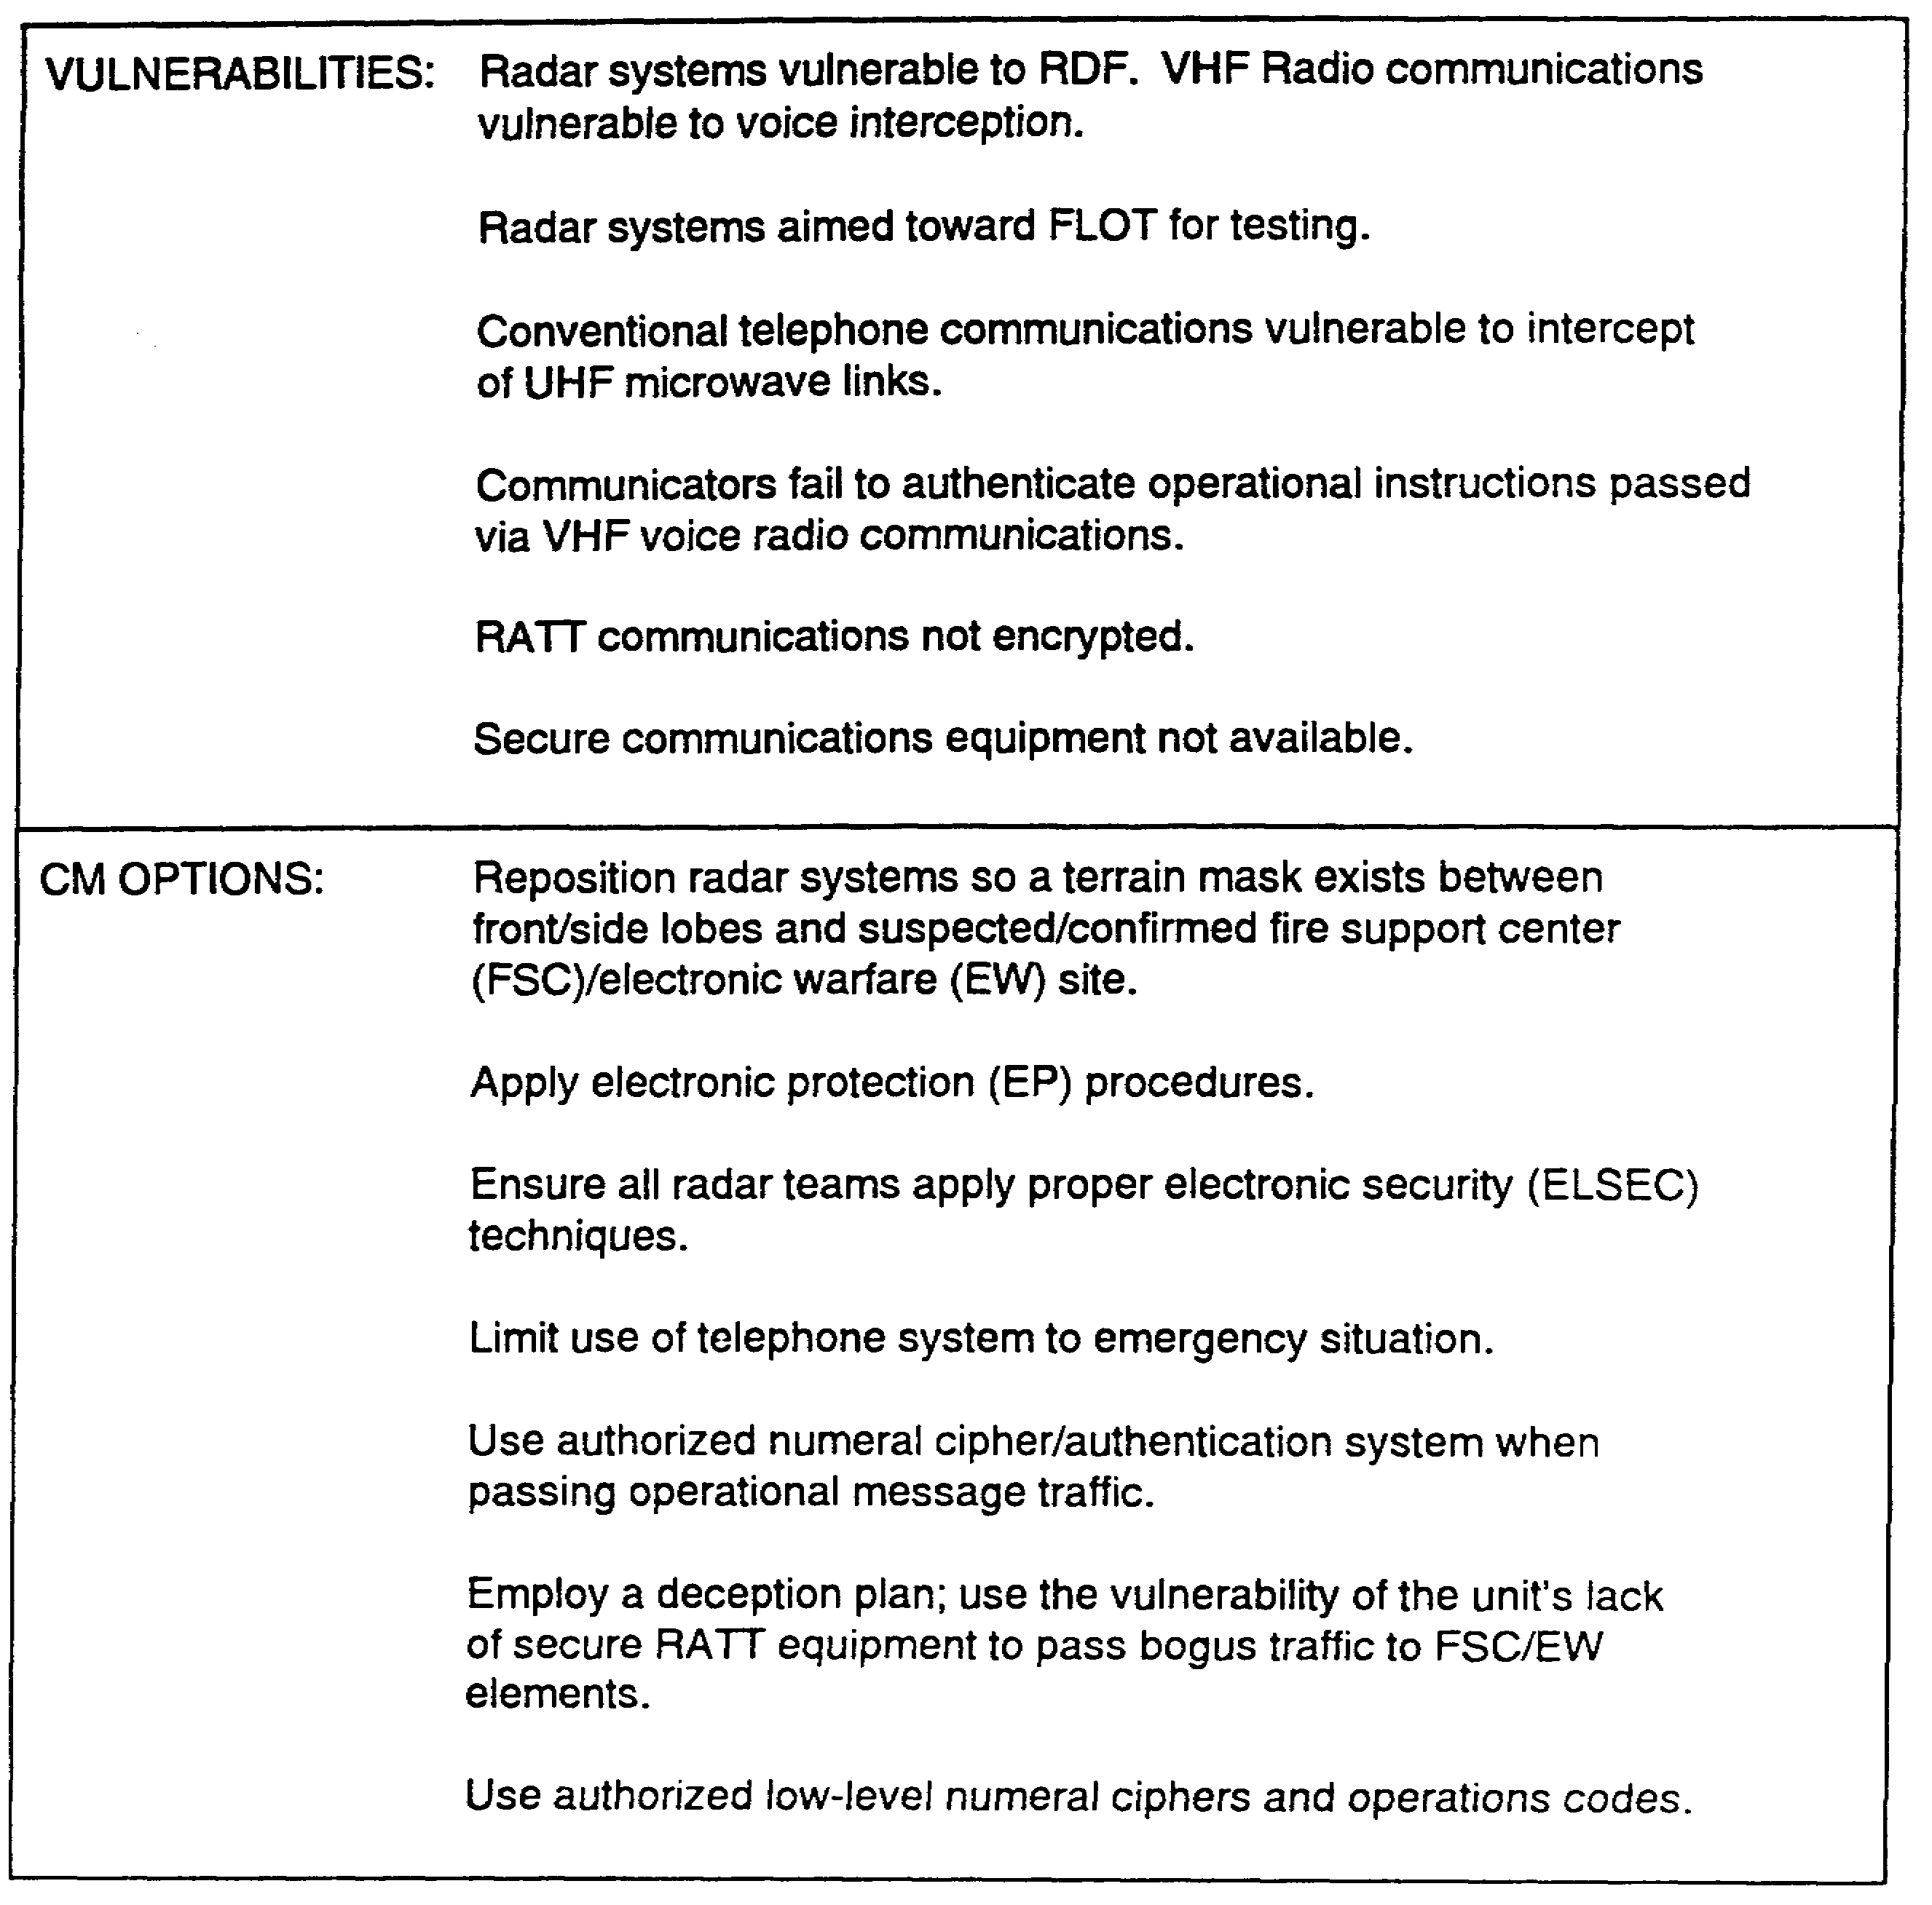

Figure 1-3. Countermeasures Options Worksheet (CM Options).

1-5 IT0843

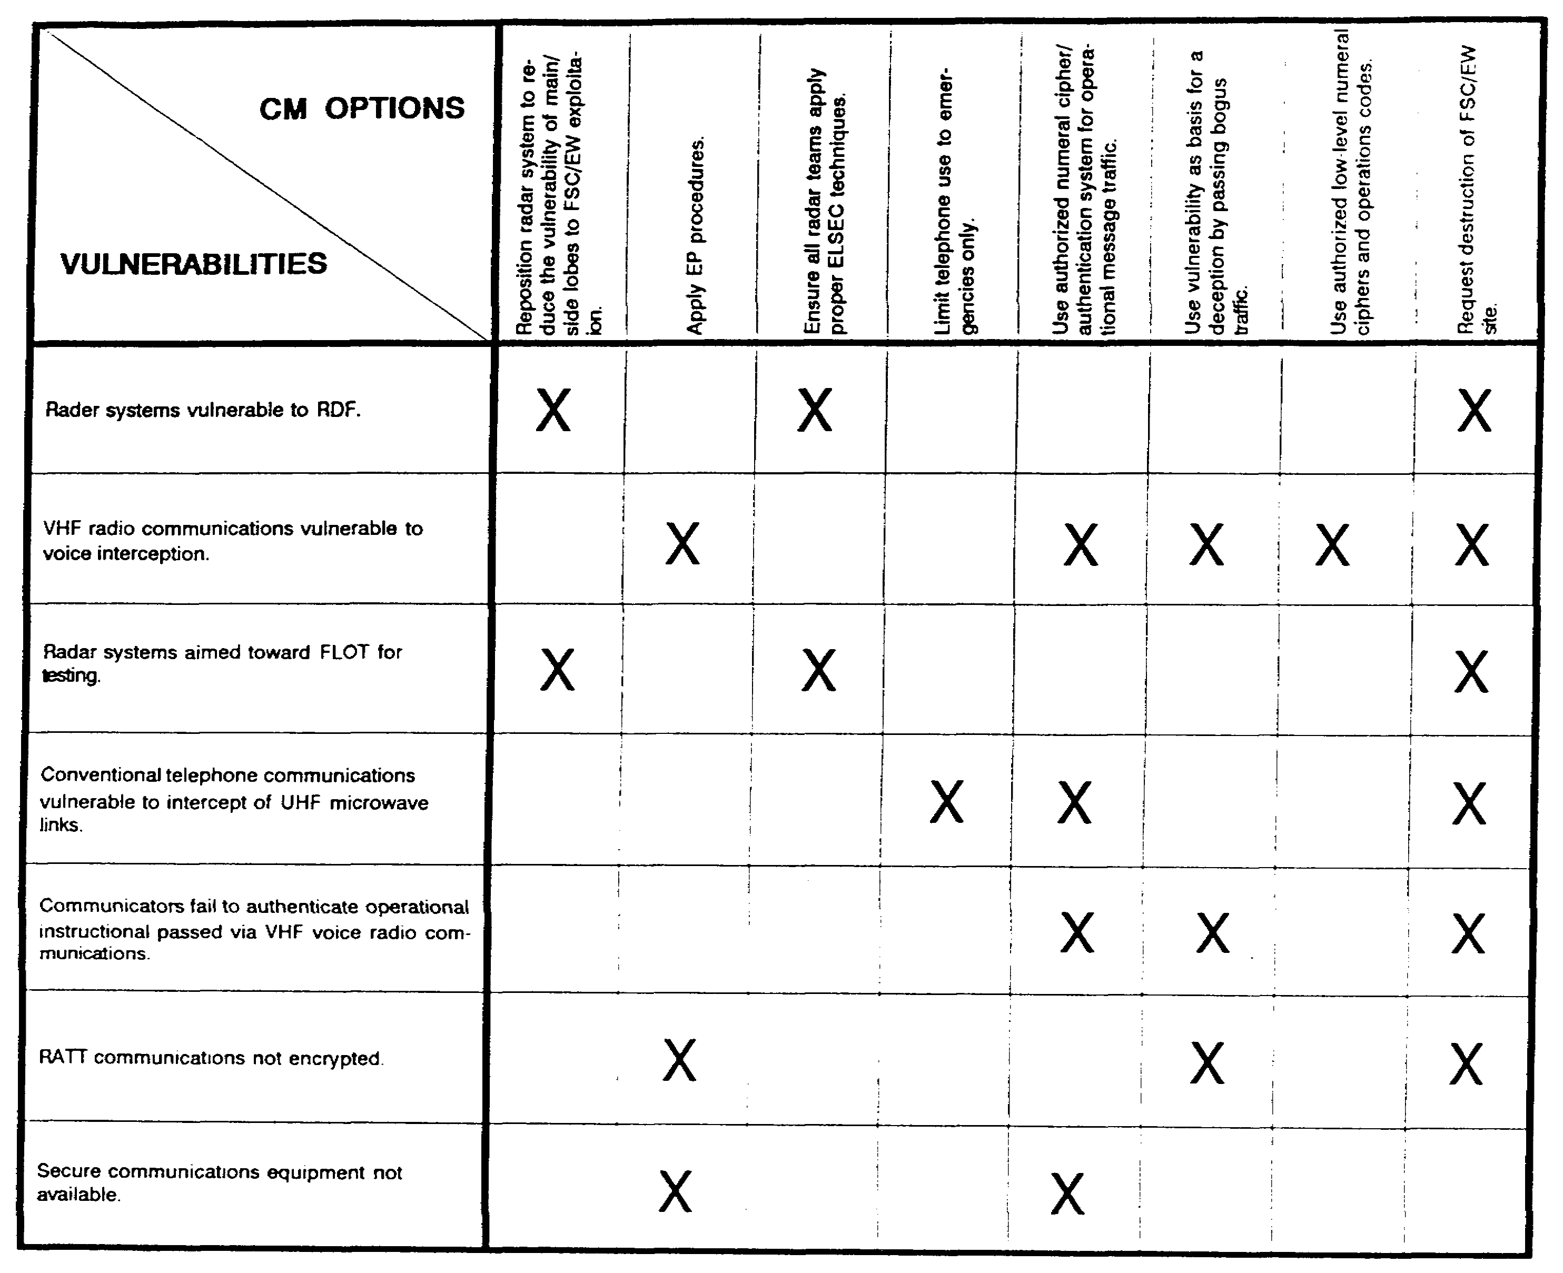

Figure 1-4. Countermeasures options matrix.

IT0843 1-6

LESSON 1

Practice Exercise

The following items will test your grasp of the material covered in this lesson. There is only one correct answer to each item. When you have completed the exercise, check your answers with the answer key that follows. If you answer any items incorrectly, study again that part of the lesson which contains the portion involved.

You are a MDCI analyst in a division-level counter-intelligence (Cl) analysis section and are tasked with conducting C-SIGINT division support. You have update the data base with the latest threat and friendly data available. You are now involved in the CM development portion of MDCI operations.

1. What is the objective of determining available CM options?

A. Support the commanders EW mission.

B. Support command operational concepts and objectives.

C. Provide logistic base protection.

D. Provide command EP support.

2. What type of information is recorded on the CM options worksheet?

A. CM options and threat assessment data.

B. Vulnerabilities and threat assessment data.

C. Confirmed CM options for provision to the commander.

D. CM options and vulnerabilities.

3. Why must you be interested in obtaining accurate information on the commander's decision?

A. Personality differences affect the manner in which commanders apply CM.

B. Commanders emphasize the use of combat power on the battlefield.

C. Personality differences in commanders are standardized by doctrine.

D. U.S. Army doctrine does not allow for flexibility in command procedures.

1-7 IT0843

LESSON 1

PRACTICE EXERCISE

Answer Key and Feedback

Item Correct Answer and Feedback

1. B. Support command operational concepts and objectives. (page 1-1)
2. D. CM options and vulnerabilities.
(page 1-2)
3. A. Personality differences affect the manner in which commanders apply CM.
(page 1-2)

IT0843 1-8

LESSON 2

CONDUCT RELATIVE BENEFIT ANALYSIS

CRITICAL TASK: 301-351-2602

OVERVIEW

TASK DESCRIPTION:

In this lesson you will learn to analyze the relative benefit of CM options.

LEARNING OBJECTIVE:

ACTIONS: Describe the information and procedures required to analyze the relative benefit of CM options.

CONDITION: To conduct relative benefit analysis.

STANDARD: Relative benefit analysis results are correct.

REFERENCE: The material contained in this lesson was derived from the following publication: FM 34-60

INTRODUCTION

The relative benefit analysis assists the commander in CM options selection with regard to resource requirements and operational impact. It provides the commander with a means of predicting the extent to which CM options are beneficial. There are four sub-tasks:

- Identify preferred CM implementation.

- Identify resource requirements.

- Develop relative benefit table.

- Evaluate shortfalls.

Identify Preferred CM Implementation

The first function to accomplish is the development of an information source listing which addresses the following subject areas:

- MDCI data base.

- CM data base.

- Doctrinal publications.

2-1 IT0843

- Technical manuals (TMs).

The MDCI analyst then collects data on the preferred CM implementation procedures for each CM from the identified data source. Identifies tasks associated with CM implementation, and collects information concerning operational requirements. An example of the process is selection of a doctrinal publication as a data source. The doctrinal publication, FM 34-60, establishes CM development implementation procedures. The following questions will help in gathering data needed to complete this task?

- What are the proper CM start-up procedures?

- What software is associated with the CM?

- What steps are involved in operating the CM?

- What are the CM terrain requirements?

- What support services are required?

Identify Resource Requirements

In determining the relative benefit, collect data on resource requirements and command availability before implementing CM (for example, hardware and/or manpower required for CM implementation) from the following sources:

- Tables of Organization and Equipment (TOE).

- Operator manuals.

- TMs

- Previous analyst experience.

Greater information insight may be gained based on past experience by accessing the MDCI and command CM data bases. The following questions will assist in collecting data from these sources:

- How many specialists are required?

- How many support personnel are required?

- What Military Occupational Specialties (MOSs) are required?

- What are the hardware configurations?

- Does the CM require specialized training?

IT0843 2-2

Develop Relative Benefit Table

At this point, the data gathering phase is completed and now to document this information onto the relative benefit table (Figure 2-1). List vulnerability as well as the associated countermeasure(s) as identified in Figure 1-4, CM options matrix are source of information for preparation of the benefit table. As indicated earlier, resource requirements must be determined. Document the expected CM result, operations impact, and shortfalls that may be expected by CM implementation. The information will be annotated on the relative benefit table as indicated in Figures 2-2 through 2-8.

Evaluate Shortfalls

In shortfall evaluation, consider each CM listed on the Relative Benefit Table. In shortfall development and alternatives, evaluate the following:

- Is the threat vulnerable?

- Will CM reduce or eliminate vulnerability?

- Is deception an effective CM?

- Is the CM developed for training or future use?

- Does the CM compliment other operations security (OPSEC) measures?

Once each CM is subjected to the previously mentioned areas, the process is considered to be complete. The shortfalls that have been determined will be documented on the Relative Benefit Table as indicated in Figure 2-2 through 2-8.

2-3 IT0843

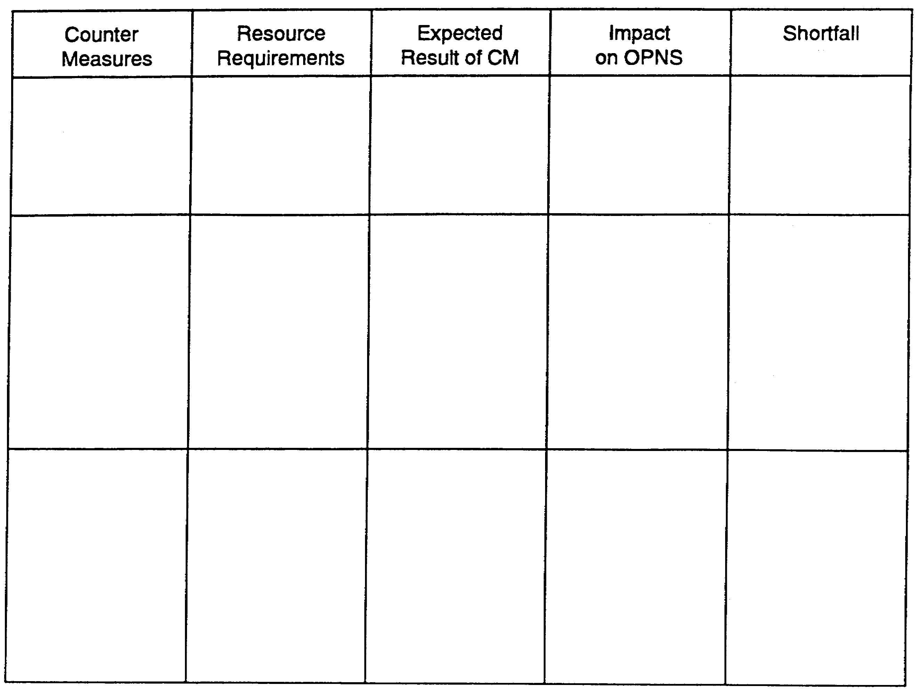

Figure 2-1. Relative Benefit Table (Blank).

IT0843 2-4

Vulnerability: Radar Systems Vulnerable to RDF

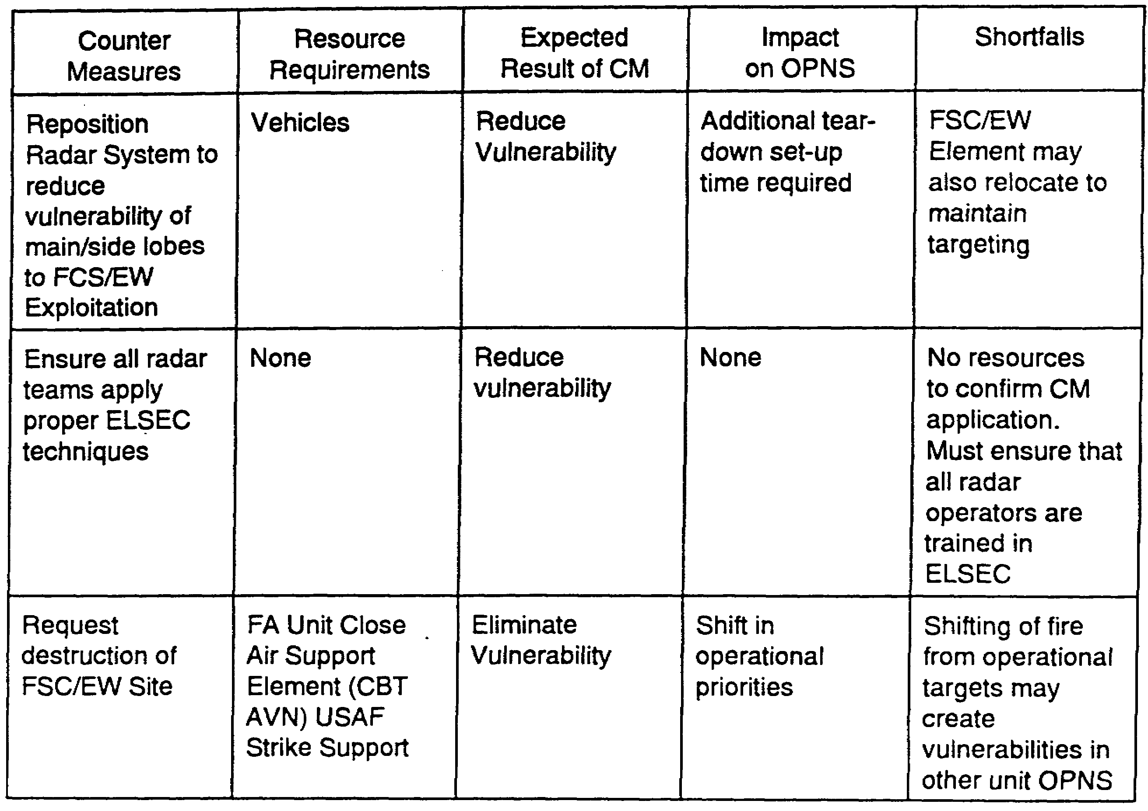

Figure 2-2. Relative Benefit Table (completed).

2-5 IT0843

Vulnerability: Secure communications equipment not available.

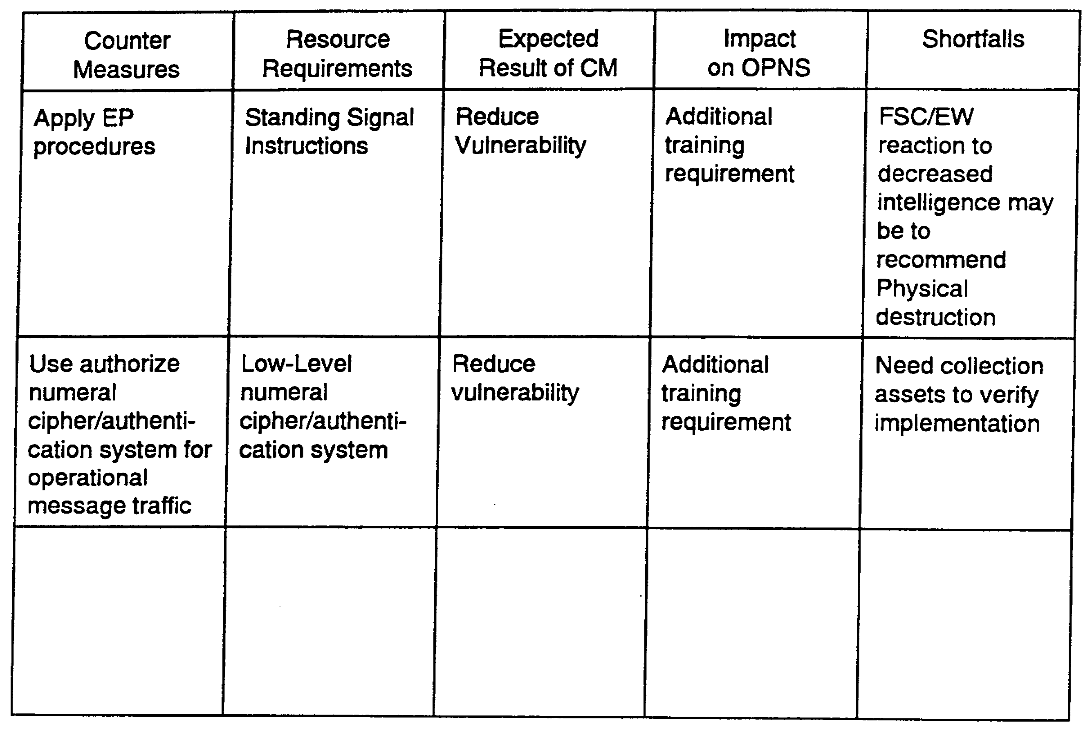

Figure 2-3. Relative Benefit Table (Completed)

IT0843 2-6

Vulnerability: RATT Communications not encrypted

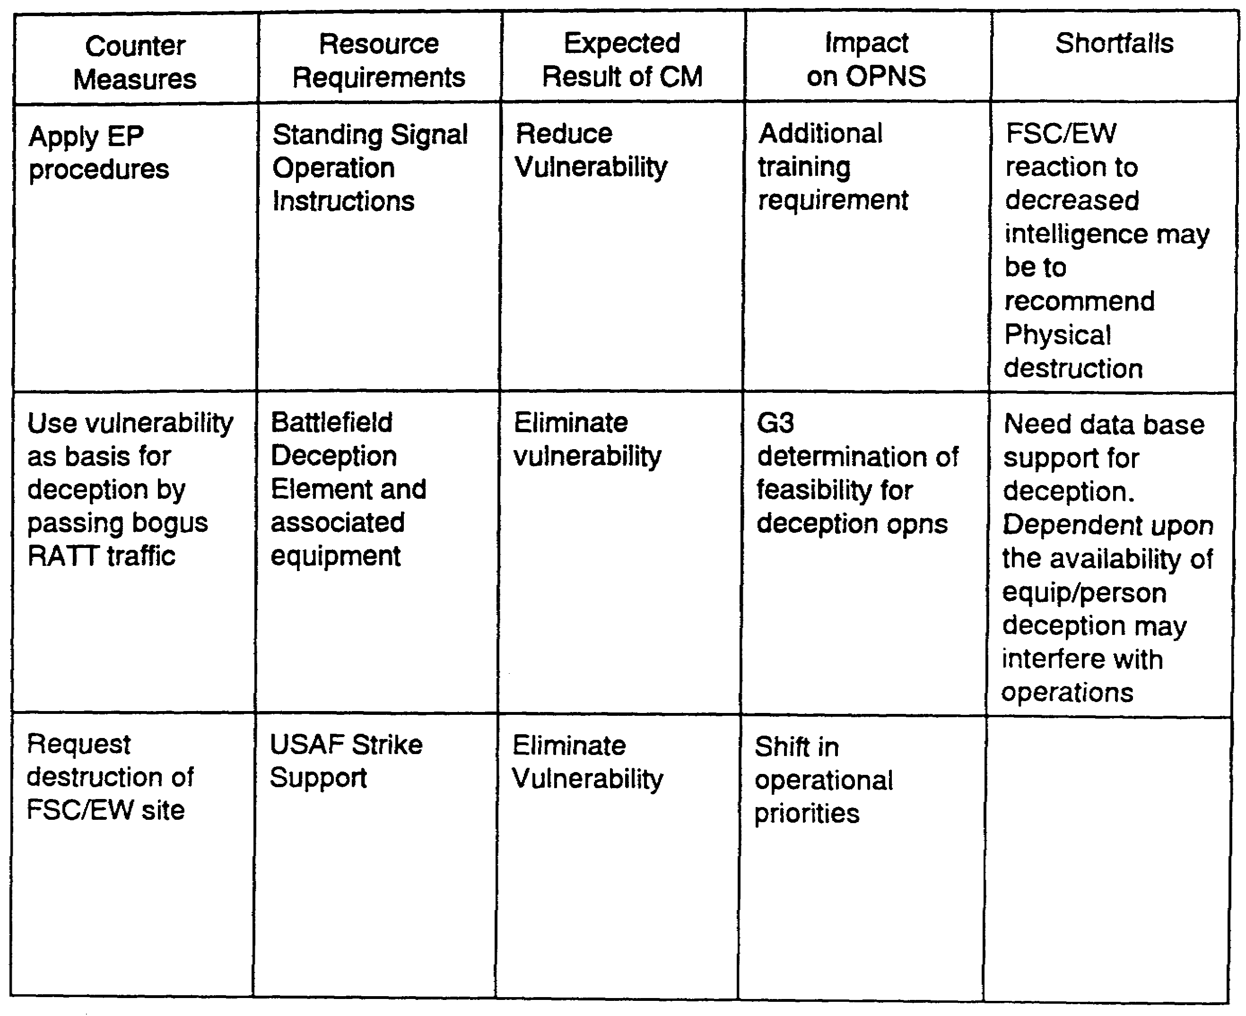

Figure 2-4. Relative Benefit Table (Completed)

2-7 IT0843

Vulnerability: Conventional telephone communications vulnerable to intercept of UHF microwave links

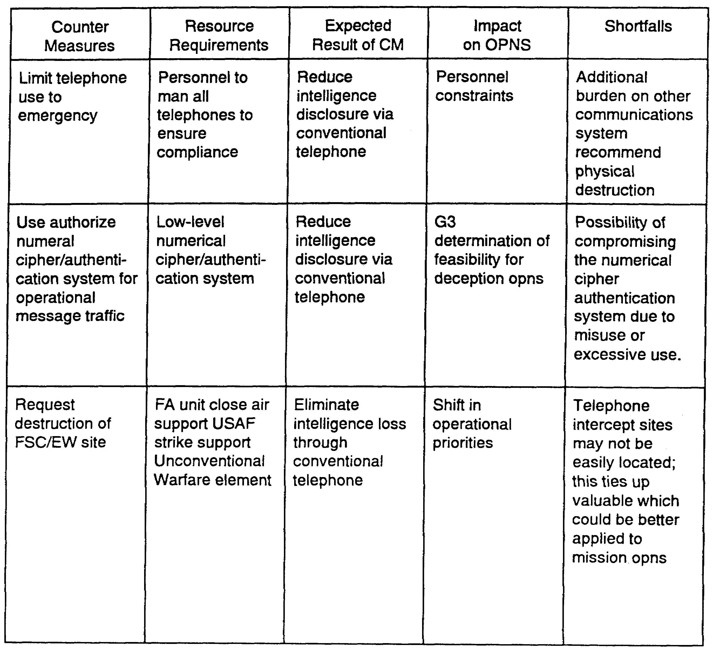

Figure 2-5. Relative Benefit Table (Completed)

IT0843 2-8

Vulnerability: Communicators fail to authenticate operational instructions passed via VHF voice radio communications.

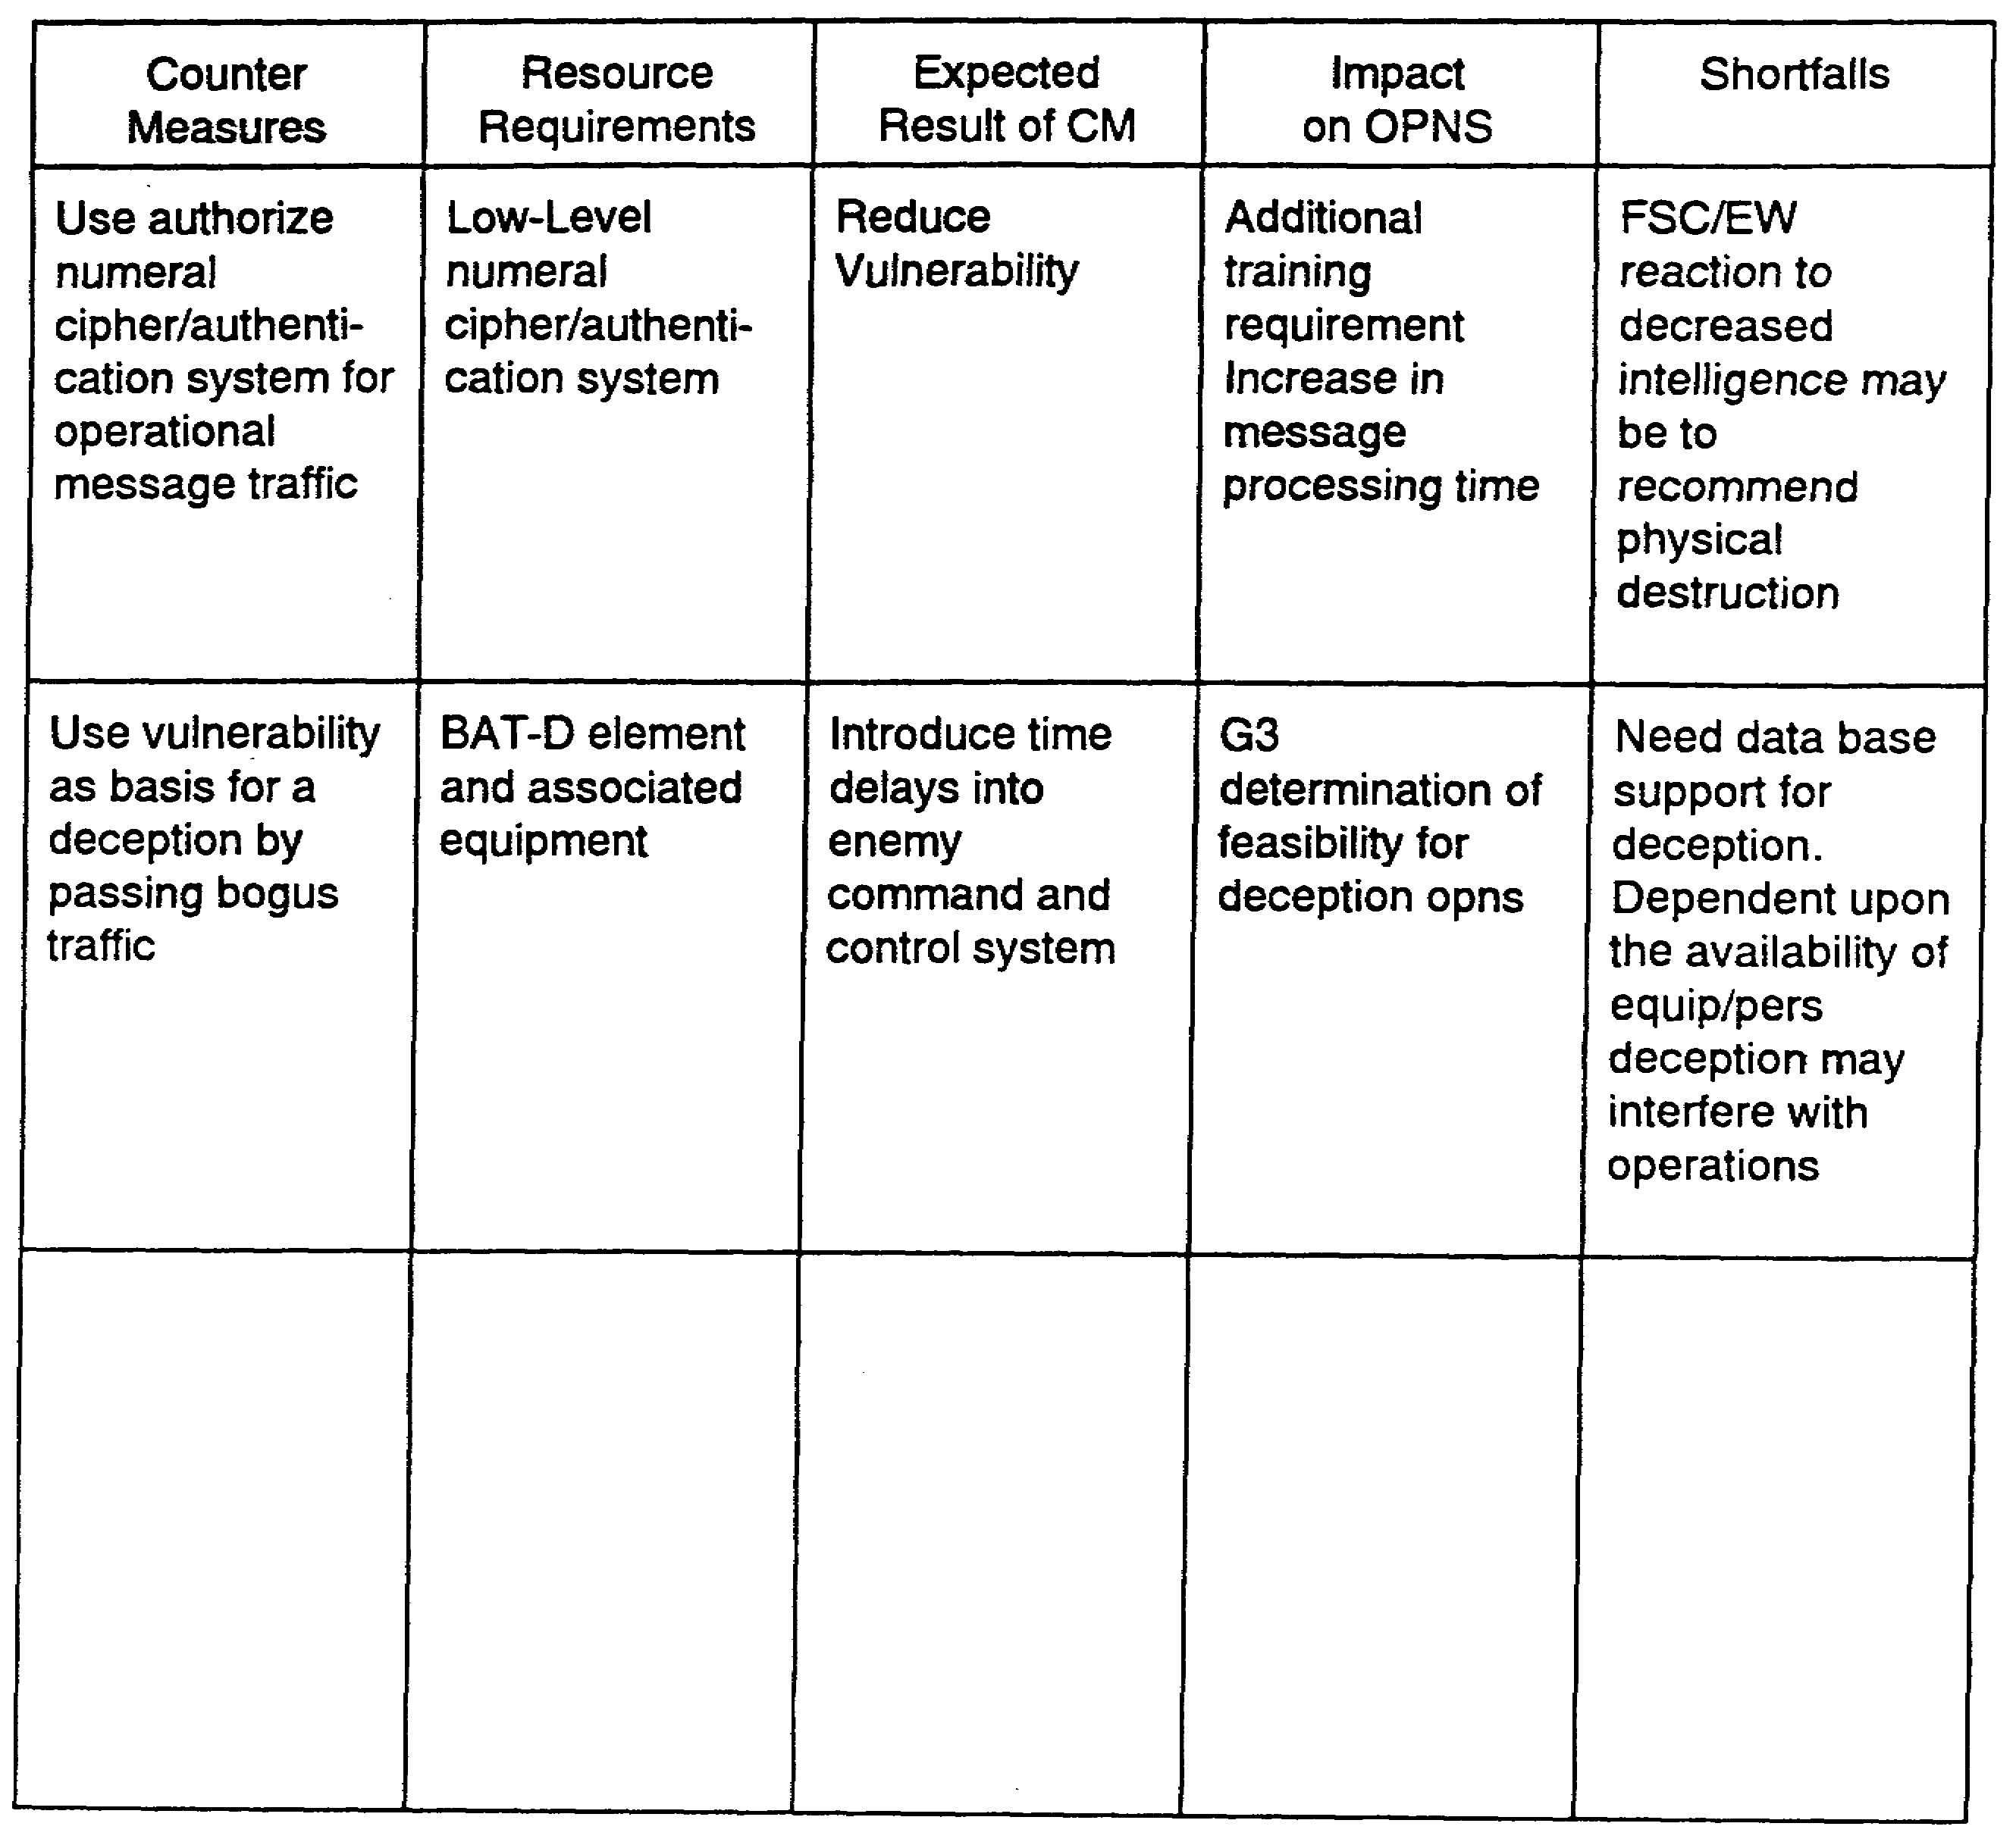

Figure 2-6. Relative Benefit Table (Completed)

2-9 IT0843

Vulnerability: Radar systems aimed toward FLOT for testing

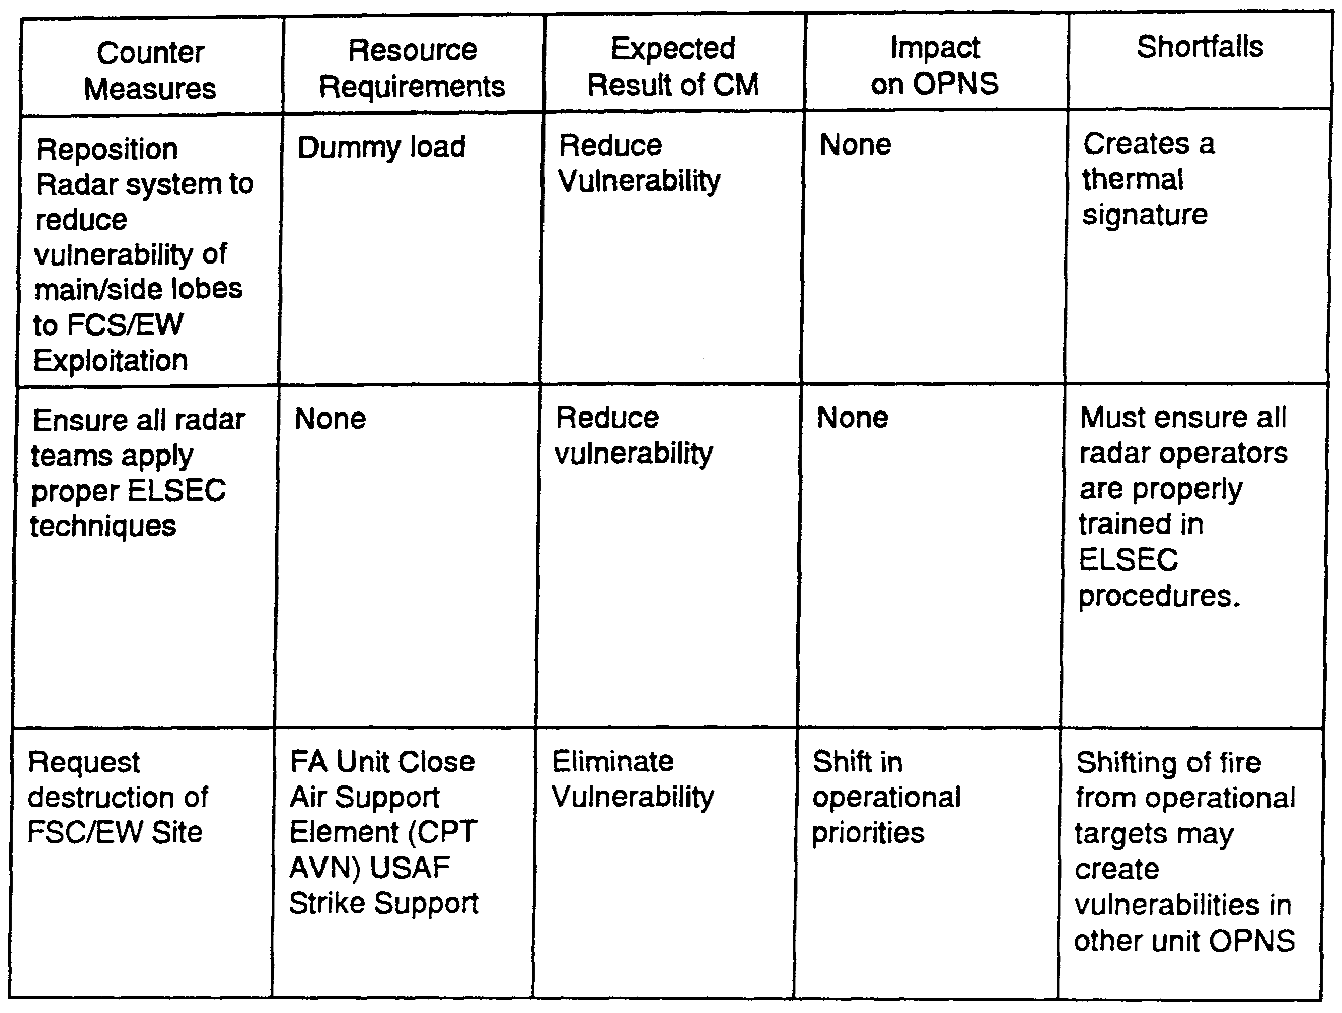

Figure 2-7. Relative Benefit Table (completed).

IT0843 2-10

Vulnerability: VHF radio communications vulnerable to voice intercept

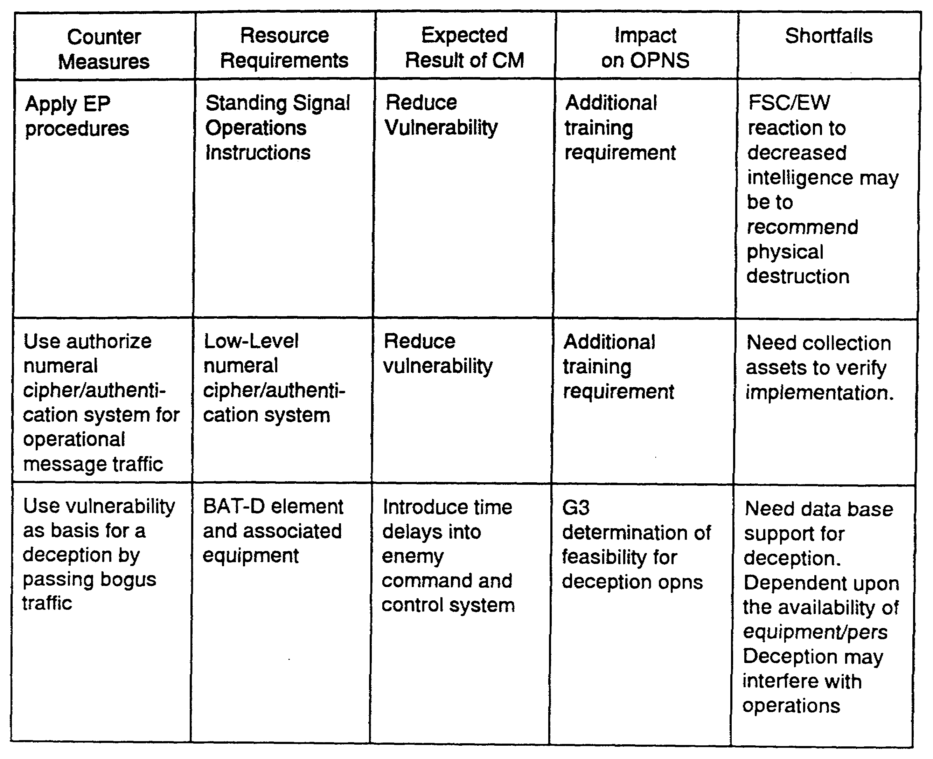

Figure 2-8. Relative Benefit Table (Completed)

2-11 IT0843

LESSON 2

PRACTICE EXERCISE

The following items will test your grasp of the material covered in this lesson. There is only one correct answer to each item. When you have completed the exercise, check your answers with the answer key that follows. If you answer any items incorrectly, study again that part of the lesson which contains the portion involved.

Having completed CM options development, you are now prepared to perform the second step in the CM development process, the conduct of the relative benefit analysis.

1. What is the first of four procedures necessary to conduct relative benefit analysis?

A. Develop proper CM start-up procedures.

B. Review doctrinal publications.

C. Identify preferred CM implementation.

D. Review TOE.

2. What data sources are available in determining resource requirements for conducting relative benefit analysis?

A. CM options worksheet.

B. Operator and technical manuals.

C. Relative benefit matrix.

D. Battlefield deception (BAT-D) plan.

3. Which of the following questions pertains to data collection to satisfy resource requirements?

A. Does CM require specialized training?

B. Are FSC/EW elements collecting against the division tactical command post (DTAC CP).

C. Is there line-of-sight (LOS) to friendly, enemy, and avenues of approach?

D. Is there adequate heliborne support for CM implementation?

IT0843 2-12

LESSON 2

PRACTICE EXERCISE

Answer Key Feedback

Item Correct Answer and Feedback

1. C. Identify preferred CM
Implementation (Page 2-1)

2. B. Operator and technical
manuals. (Page 2-2)

3. A. Does the CM require
specialized training? (Page 2-3)

IT0843 2-14

LESSON 3

CONDUCT RISK ASSESSMENT

CRITICAL TASK: 301-351-2601

OVERVIEW

TASK DESCRIPTION: In this lesson you will learn how to conduct a risk assessment.

LEARNING OBJECTIVE:

ACTIONS: Describe the information and procedures required to conduct risk assessment.

CONDITION: To develop a risk assessment matrix.

STANDARD: To correctly identify risk assessment procedures.

REFERENCE: The material contained in this lesson was derived from the following publication: FM 34-60

INTRODUCTION

Risk assessment predicts the elements of risk to operations associated with the compromise of an Essential Elements of Friendly Information (EEFI) subject. This task involves development of a risk assessment matrix. The MDCI analyst must access the following data sources in order to complete the risk assessment matrix:

- MDCI data base.

- Current activities.

- CM data base.

- Past actions.

- OPSEC evaluation management plan.

- Hostile doctrine.

- Threat data.

- EEFI.

- Vulnerability data.

- CM options list.

3-1 IT0843

Relative Benefit Matrix

The risk assessment matrix (Figure 3-1) is a tool to determine operational risks when a CM is not applied or does not successfully reduce or eliminate friendly vulnerabilities. The MDCI analyst assigns a value to the vulnerability as well as to past CM success. These values must relate to specific EEFI items. The following scale establishes this relationship:

VULNERABILITY PART CM SUCCESS

5 - CRITICAL 5 - HIGH

2- SIGNIFICANT 2- MEDIUM

1 - IMPORTANT 1 - MARGINAL

0 - UNIMPORTANT 0- FAILURE

The risk assessment matrix is prepared in the following manner:

BLOCK 1: List CM options from CM options list developed in Lesson 1.

BLOCK 2: List specific EEFI.

BLOCK 3: Assign a numerical value to the EEFI vulnerability item (5, 2, 1, 0).

BLOCK 4: Assign a numerical value to past CM success.

BLOCK 5: Determine risk factor by applying the following algorithm:

VULNERABILITY - PAST SUCCESS = RISK FACTOR.

Place risk factor value in Block 5.

BLOCK 6: Annotate risk elements in this block. The risk element is determined by applying the risk factor in Block 5 to the following scale:

4-5 High risk.

2-3 Medium risk.

0-1 Low risk.

Task completion requires a value judgement based on the previously mentioned information sources in order to determine the numerical risk element. Figure 3-2 is an example of a completed risk assessment matrix.

IT0843 3-2

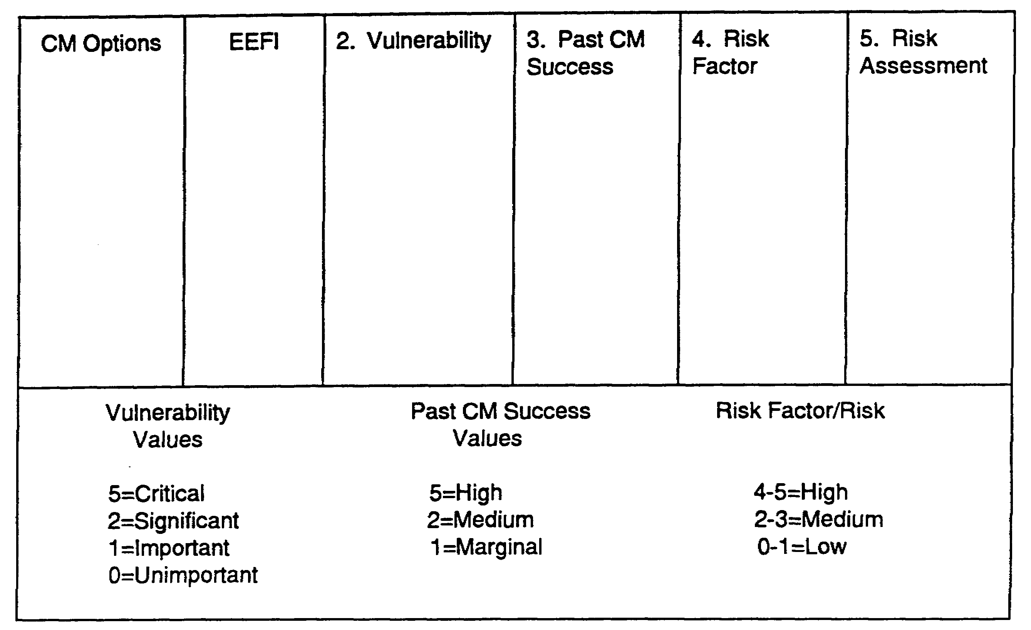

Figure 3-1. Risk Assessment Matrix (Blank)

3-3 IT0843

LESSON 3

Practice Exercise

The following items will test your grasp of the material covered in the lesson. There is only one correct answer to each item. When you have completed the exercise, check your answers with the answer key that follows. If you answer any item incorrectly, study again that part of the lesson which contains the portion involved.

Risk assessment is the next task to complete in CM options development for the commander.

This provides him with a means of estimating the risk to operations when a CM is not applied or does not successfully reduce or eliminate friendly vulnerabilities. Identify the procedures for completing the risk assessment matrix.

1. What information is contained in the third block of the risk assessment matrix.

A. Past CM success.

B. A numerical value to the EEFI item vulnerability.

C. The risk element from low to high.

D. An algorithm for risk factor determination.

2. What value is given to a vulnerability that is determined to be significant?

A. 5.

B. 4.

C. 3.

D. 2.

3. How is past CM success measured?

A. High, medium, and low.

B. High, medium, marginal, and failure.

C. Important, significant, and critical.

D. Critical, marginal, and insignificant.

IT0843 3-4

LESSON 3

PRACTICE EXERCISE

Answer Key and Feedback

Item Correct Answer and Feedback

1. B. A numerical value to the
vulnerability of the EEFI item. (Page 3-2)

2. D. 2. (Page 3-2)

3. B. High, Medium, marginal and failure. (Page 3-2)

IT0843 3-6

LESSON 4

CONDUCT COMPARISON OF BENEFIT TO RISK

CRITICAL TASK: 301-351-2602

TASK DESCRIPTION:

In this lesson you will learn to compare benefit to risk.

LEARNING OBJECTIVE:

ACTIONS: Describe the information and procedures required to conduct a comparison of benefit to risk.

CONDITION: To determine relative CM benefit.

STANDARD: To correctly conduct a benefit to risk comparison.

REFERENCE: The material contained in this lesson was derived from he following publication: FM 34-60

INTRODUCTION

Having completed risk assessment regarding each countermeasure, now determine the relative benefit associated with each CM compared to the assessed risk of using the CM. There are two associated sub-tasks:

- Evaluate benefit.

- Evaluate risk.

The purpose of the benefit to risk comparison is to determine the relationship between the specific risk of implementing a particular CM and the operational benefit realized through implementing that CM. The following data sources may be used to analyze benefit to risk:

- MDCI data base.

- CM data base.

- Doctrinal Publications data.

Evaluate Benefit

Use the relative benefit table (Figures 2-2 through 2-8) to compare the expected CM implementation result with its projected impact on operations and resource requirements (for example, if the operational impact is low, few resources are required, and expected CM implementation results are high, the expected relative benefit will be high. Conversely, if the expected result is low, sever operations impact, and the CM requires extensive resources, the

4-1 IT0843

relative benefit must be considered low). A value of High, Medium, or Low is placed on the benefit to risk form (Figure 4-1).

Evaluate Risk

In order to evaluate risk, review the risk assessment matrix (Figure 3-2) and extract risk assessment data from Block 5. The extracted value is entered on the benefit to risk form (Figures 4-2 and 4-3). Once this form is completed, the risk associated with the relative benefit of each CM is determined.

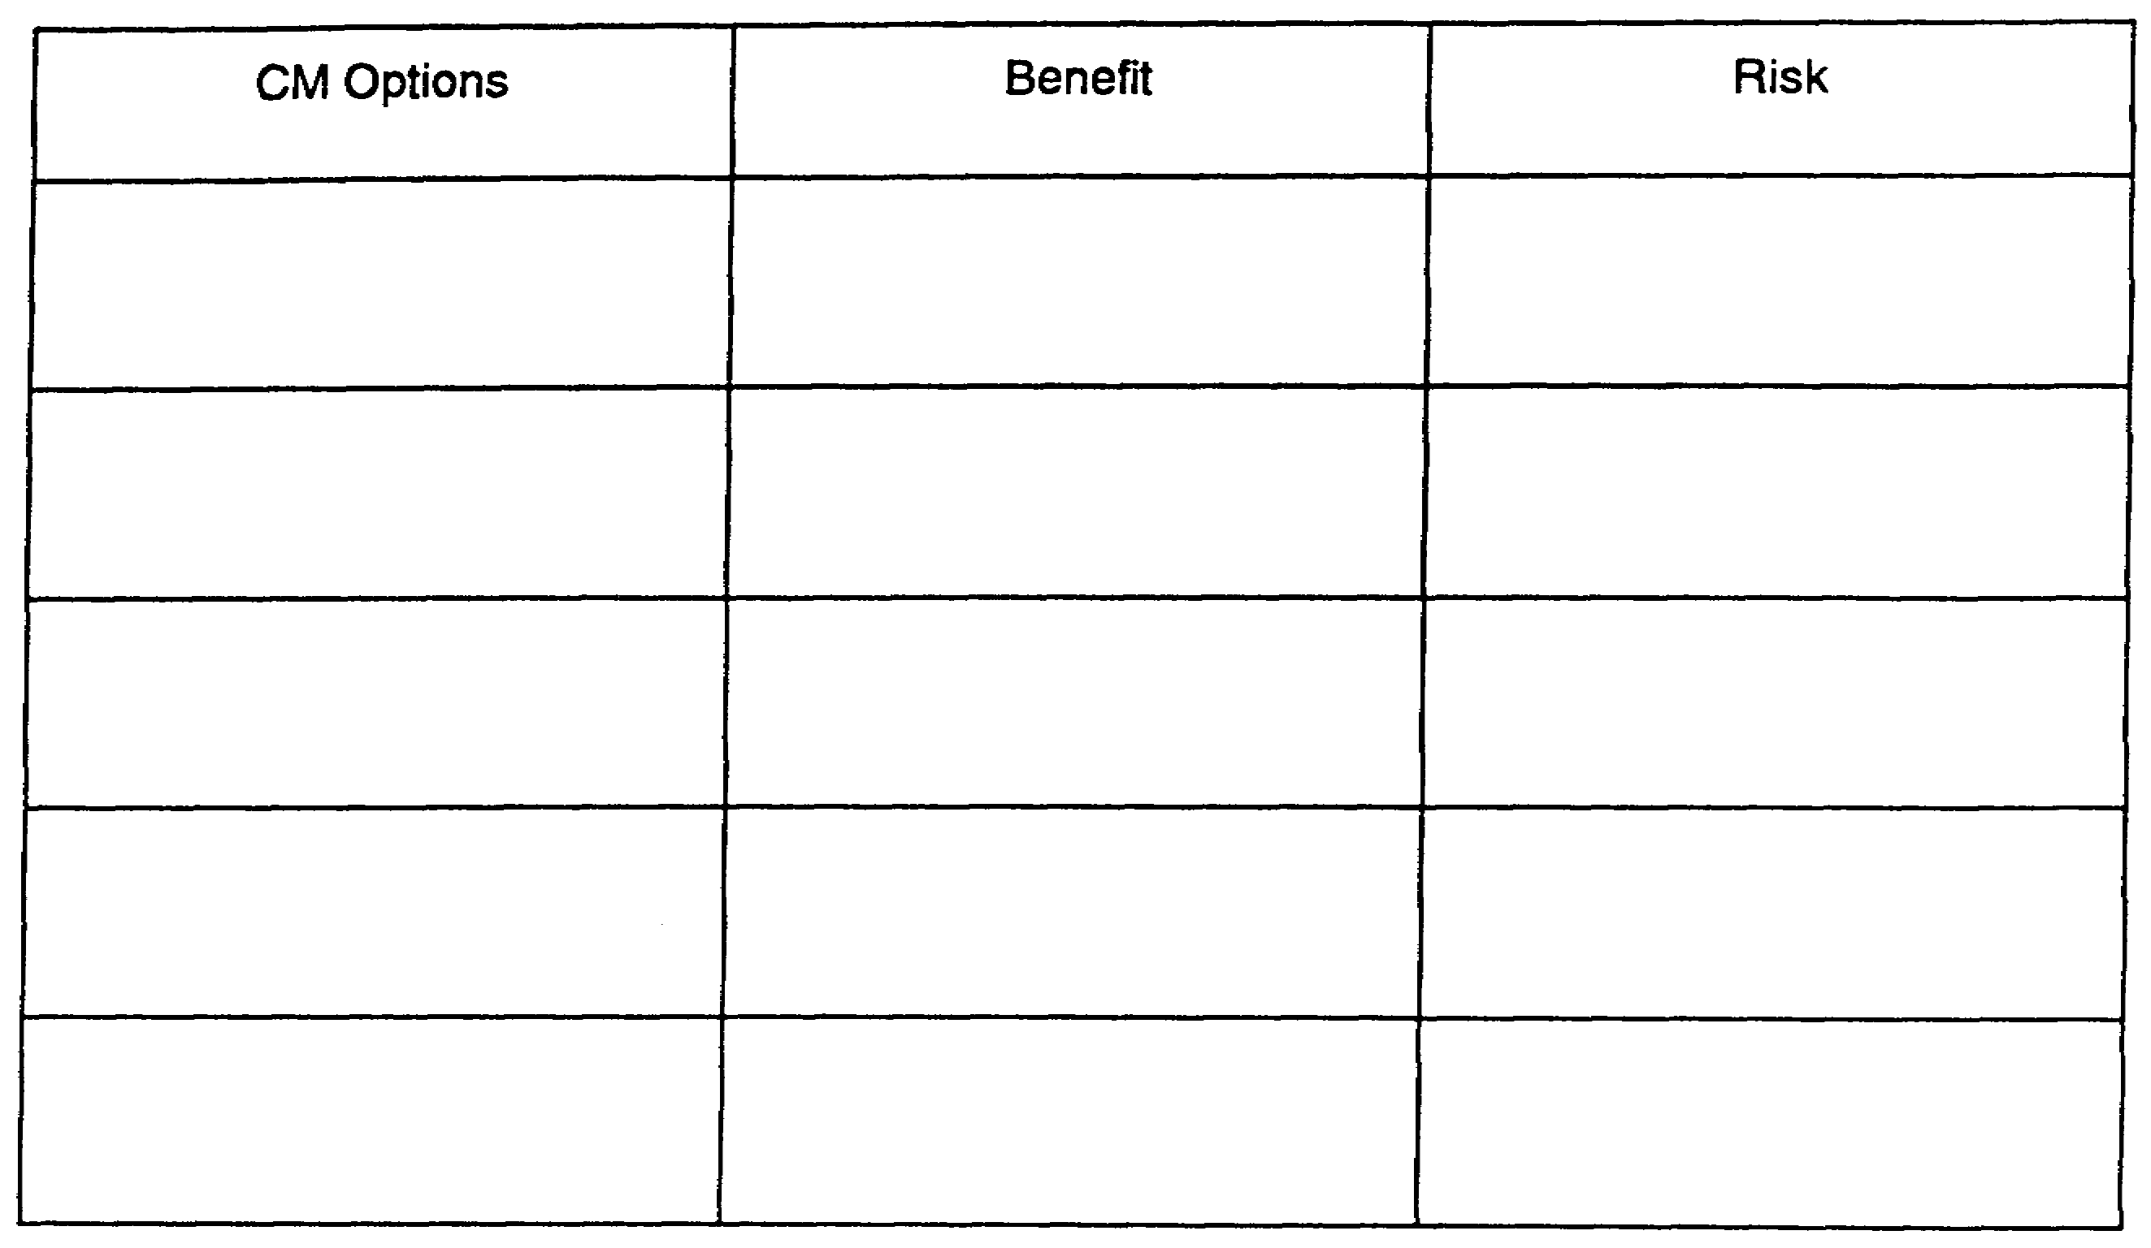

Figure 4-1. Benefit to Risk Form (Blank).

IT0843 4-2

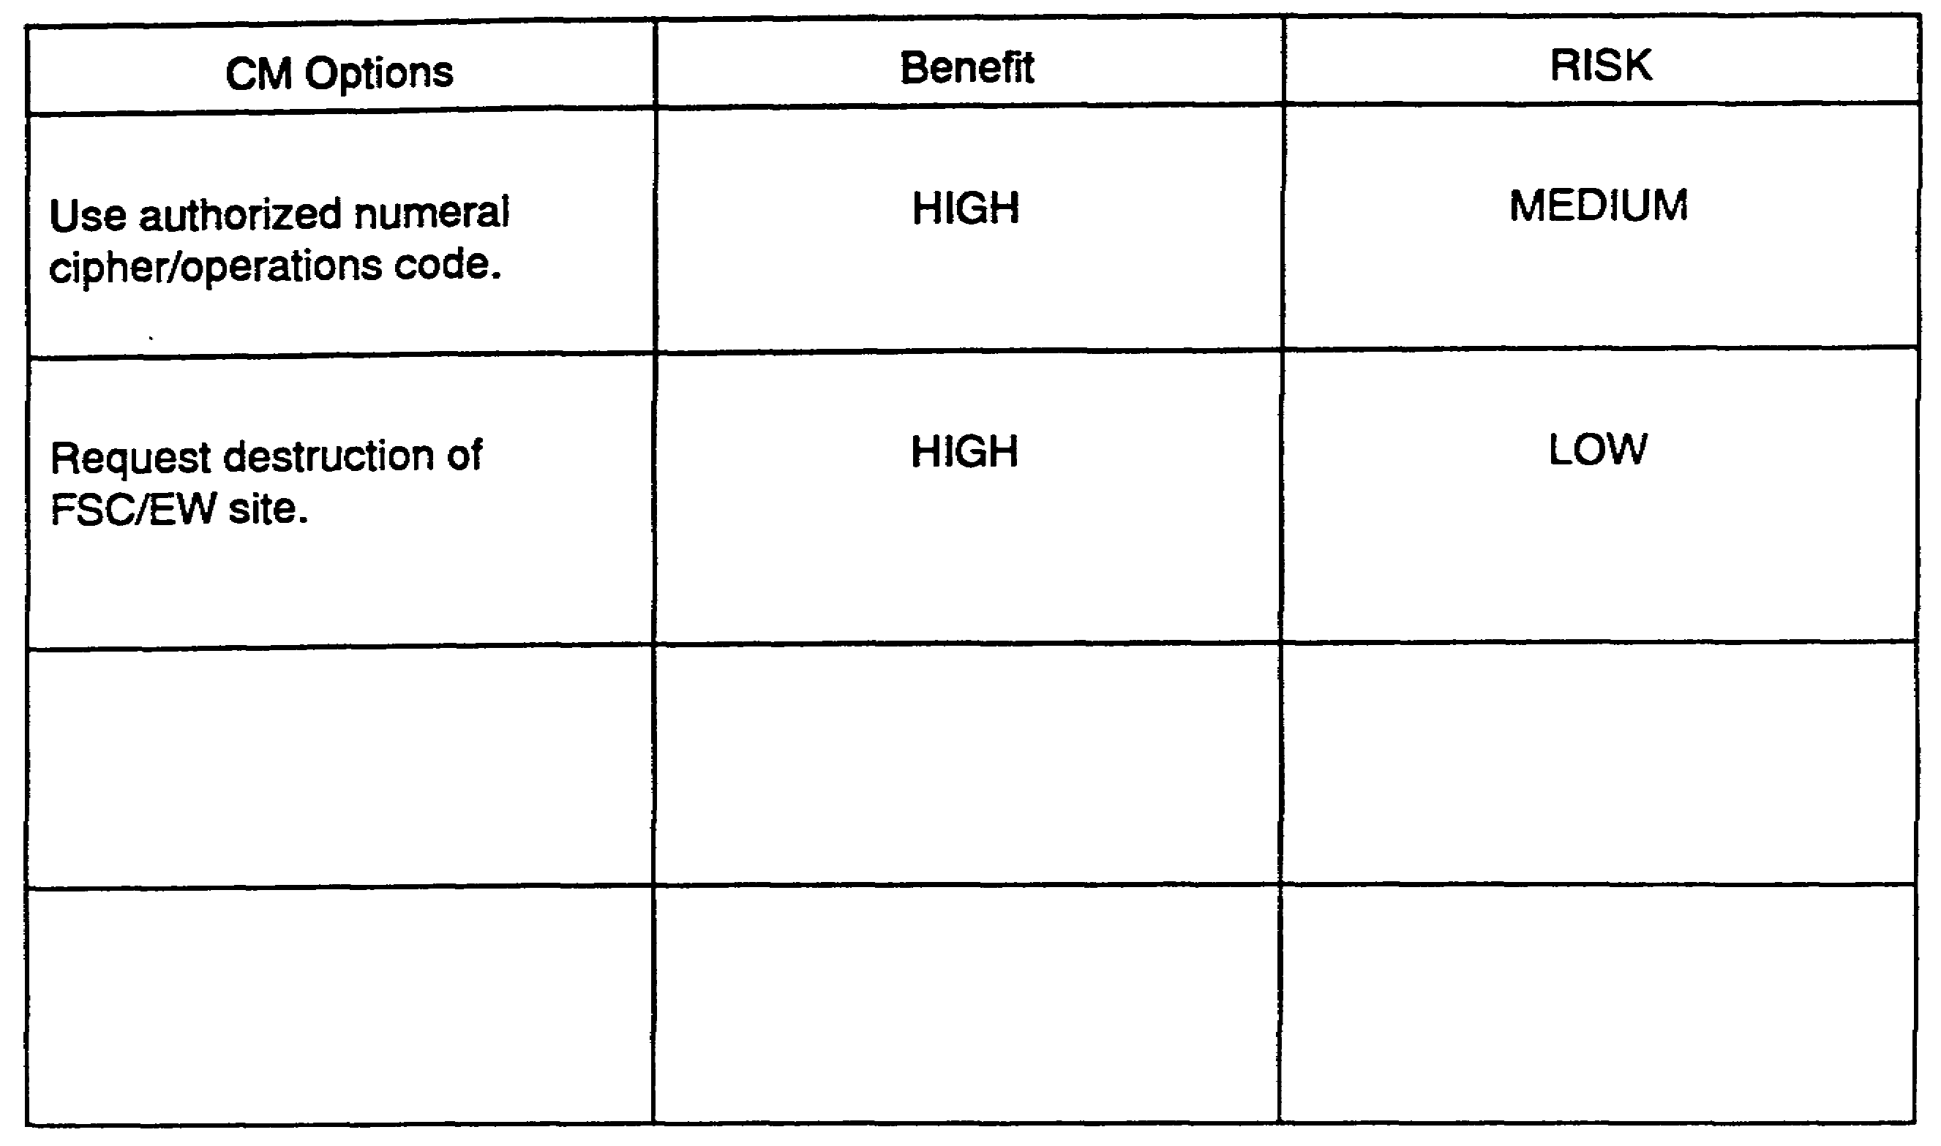

Figure 4-2. Benefit to Risk Form (Completed).

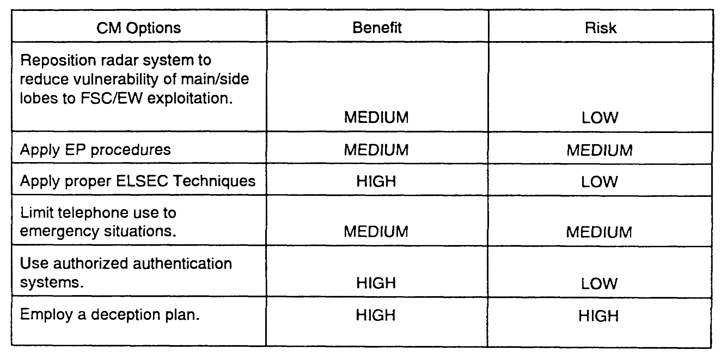

Figure 4-3. Benefit to Risk Form (Completed)

4-3 IT0843

LESSON 4

Practice Exercise

The following items will test your grasp of the material covered in this lesson. There is only one correct answer to each item. When you have completed the exercise, check your answers with the answer key that follows. If you answer any item incorrectly, study again that part of the lesson which contains the portion involved.

You are conducting a comparison of benefit to risk in order to properly advise the commander on Cm implementation.

1. How many tasks are associated with the comparison of benefit to risk?

A. 4.

B. 3.

C. 2.

D. 1.

2. In the evaluation of benefit, what specific functions from the relative benefit table are considered?

A. Vulnerability assessment.

B. CM evaluation.

C. Shortfalls.

D. Impact on operations.

3. What type information is extracted from Block 5 of the Risk Assessment Matrix?

A. Risk assessment data.

B. Past CM success.

C. Vulnerability assessment.

D. EEFI listing.

IT0843 4-4

LESSON 4

PRACTICE EXERCISE

Answer Key and Feedback

Item Correct Answer and Feedback

1. C. 2. (Page 4-1)

2. D. Impact on operations. (Page 4-2)

3. A. Risk assessment data. (Page 4-3)

IT0843 4-6

LESSON 5

DEVELOP PRIORITIZED COUNTERMEASURES OPTIONS LIST

CRITICAL TASK: 301-351-3601

TASK DESCRIPTION:

In this lesson you will learn to develop a prioritized CM options list.

LEARNING OBJECTIVE:

ACTIONS: Describe the information and procedures required to develop a prioritized CM options list.

CONDITION: To provide supported commander with viable CM options.

STANDARD: To correctly develop a prioritized CM options list.

REFERENCE: The material contained in this lesson was derived from the following publication: FM 34-60

INTRODUCTION

The knowledge gained to prepare a prioritized CM options list is now applied. This task performed by the MDCI specialist is expressed directly to the commander. This culminates the CM development process. The prioritized CM options list is essential in providing the supported commander, and his operations planning staff, with CM options to reduce or eliminate identified vulnerabilities. The MDCI specialist must subscribe to various data sources to accomplish this task to include the following:

- Benefits assessment.

- Risk assessment.

- Benefits to risk assessment.

The three sub-task associated with this task are to prepare CM:

- Effectiveness.

- Costliness.

- Priority list.

Prepare CM effectiveness

Using the CM effectiveness to costliness worksheet (Figure 4-3), list all CM options in order from most to least effective. take the following situation for example: If jamming, destruction, EP, and

5-1 IT0843

relocation are the CM options, the values in terms of effectiveness will appear in the following order:

- Destruction.

- Electronic Protection (EP).

- Electronic Attack (EA).

- Relocation.

The number preceding each CM is now the CM effectiveness value.

Prepare CM costliness

Using the CM effectiveness to costliness worksheet (Figure 5-1), list all CM options in order from the least to most costly. If the CM options are jamming, destruction, relocation, and EP, the costliness column would appear as follows:

- EP.

- EA.

- Relocation.

- Destruction.

The number preceding each CM is now the CM costliness value.

Prepare CM Priority List

Using the CM effectiveness to costliness worksheet, add the number in the effectiveness column to the number in the costliness column to determine the CM which is the most effective and least costly. The lower the total, the higher the CM priority. The prioritized CM list resulting from a comparison of values which appear in paragraphs one and two are:

EFFECTIVENESS COSTLINESS

1. Destruction. 1. EP.

2. EP. 2. EA.

3. EA. 3. Relocation.

4. Relocation. 4. Destruction.

IT0843 5-2

The prioritized CM list resulting from this example is:

1. EP.

2. EA.

3. Destruction.

4. Relocation.

This information is formatted in an information briefing and presented to the commander and his operational planning staff. It is also documented in memorandum format for record purposes. An example of a CM effectiveness to costliness worksheet appears in Figure 5-2.

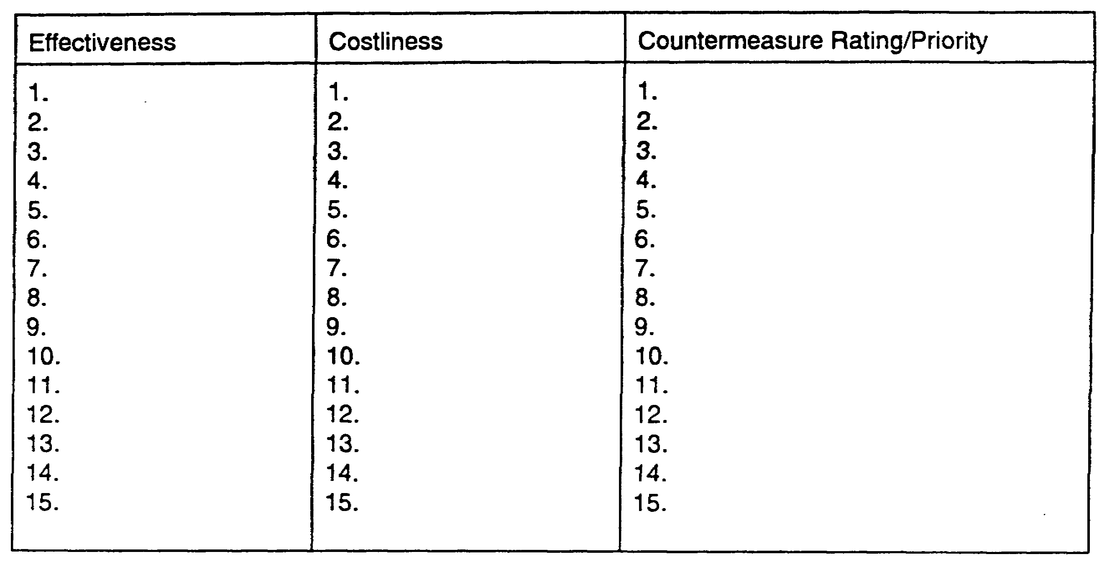

Figure 5-1. CM Effectiveness to Costliness Worksheet (Blank)

Countermeasure Effectiveness will be listed from MOST to LEAST effective.

Countermeasure Costliness will be listed from LEAST to MOST costly.

The number from the effectiveness column will be added to the number in the costliness column to determine the countermeasure which is the most effective and least costly. This produces a prioritized list of countermeasures. The countermeasure with the lowest total in terms of effectiveness to costliness will receive the highest priority.

5-3 IT0843

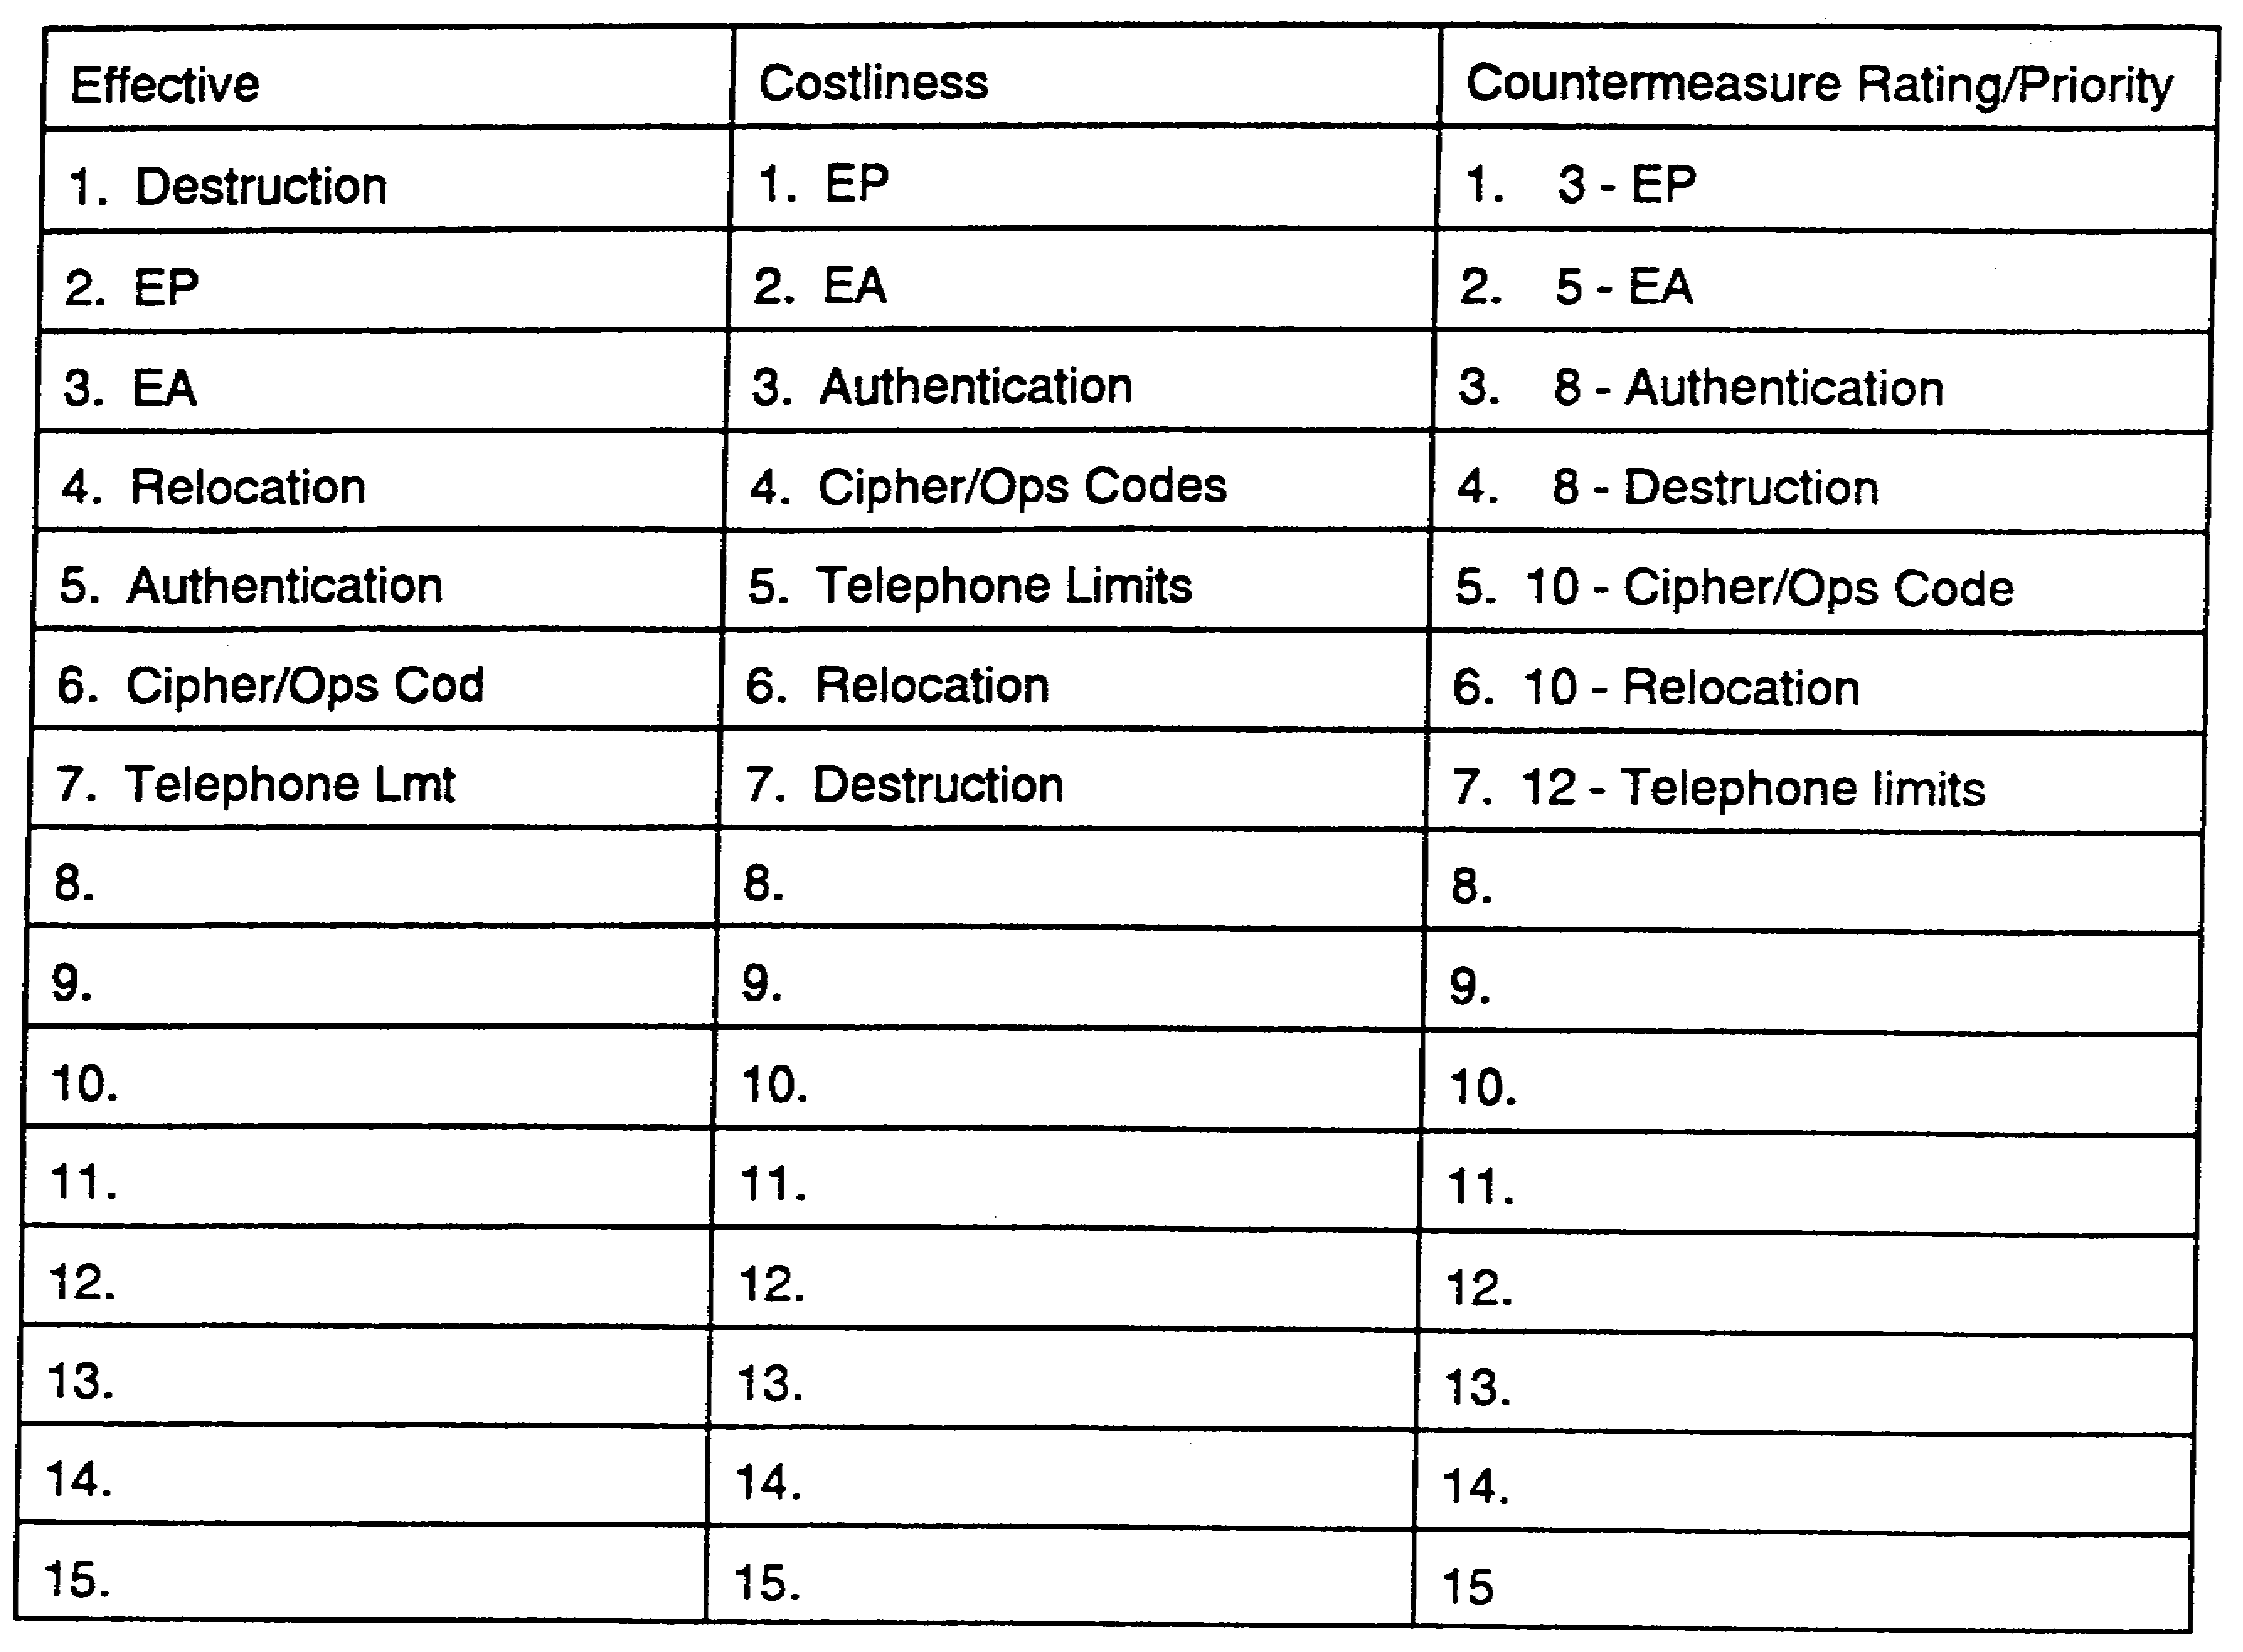

Figure 5-2. CM Effectiveness to Costliness Worksheet (Completed)

Countermeasure Effectiveness will be listed from MOST to LEAST effective.

Countermeasure Costliness will be listed from LEAST to MOST costly.

The number from the effectiveness column will be added to the number in the costliness column to determine the countermeasure which is the most effective and least costly. This produces a prioritized list of countermeasures. The countermeasure with the lowest total in terms of effectiveness to costliness will receive the highest priority.

IT0843 5-4

LESSON 5

Practice Exercise

The following items will test your grasp of the material covered in this lesson. There is only one correct answer to each item. When you have completed the exercise, check your answers with the answer key that follows. If you answer any item incorrectly, study again that part of the lesson which contains the portion involves.

The information resulting from the development of a prioritized CM operations list is provided the commander. This allows him to select the appropriate CM to match the vulnerability. He also has an option of accepting the risk and not implementing any CM.

1. Which of the following is a viable CM option?

A. Radio electronic combat (REC).

B. FSC/EW threat assets.

C. Relocation of friendly C-E emitters.

D. Terminal jamming.

2. How many sub-tasks must be accomplished in order to develop a prioritized CM options list?

A. 3.

B. 4.

C. 5.

D. 6.

3. What are two methods or media used in presenting the results of the prioritized CM options development to command and staff?

A. Risk assessment matrix and prioritized CM options list.

B. CM options worksheet and relative benefit analysis.

C. Briefing and memorandum.

D. Lecture and conference.

5-5 IT0843

LESSON 5

PRACTICE EXERCISE

Answer Key and Feedback

Item Correct Answer and Feedback

1. C. Relocation of friendly C-E
emitters. (Page 5-2)

2. A. 3 (Page 5-1)

3. C. Briefing memorandum (Page 5-3)

IT0843 5-6

LESSON 6

PRODUCE OUTPUT

TASK DESCRIPTION:

In this lesson you will learn how to present countermeasures to the command in an oral or written format.

LEARNING OBJECTIVE:

ACTIONS: Describe the contents of a countermeasures briefing, report, and message.

CONDITIONS: To present the prioritized list to the command.

STANDARDS: To correctly identify countermeasures briefing, report, and message contents, and the United States Message Text Format (USMTF).

REFERENCES: The material contained in this lesson was derived from the following publication: FM 34-60

INTRODUCTION

Once CM are developed, they are prioritized based upon effectiveness and costliness. The prioritized list, which is the output, is presented to the command as a briefing, report, or message. The MDCI output is normally incorporated into the analysis and control element (ACE) or the BAT-D Cell command input. The objective of this lesson is to present CM to the command in an oral or written format. The three sub-tasks in this task are to prepare a CM:

- Briefing.

- Report.

- Message.

Prepare a CM Briefing. CM are not necessarily presented to the command separately by MDCI personnel. A consolidated briefing from the ACE or BAT-D Cell includes MDCI recommendations.

In order to present CM to the command, it is necessary to know a military briefing format. General briefing contents are stated in FM 101-5, Appendix C. A briefing consists of three main parts.

The introduction is intended to define the subject and to orient the listener. Do not utilize "attention getters" or dramatics.

- Greeting. Use military courtesy. Address the person(s) to be briefed. identify oneself.

- State classification level. If the briefing is unclassified, then so state, the briefing will be classified according to content in accordance with (IAW) Army Regulation (AR) 380-5, Department of the Army Information security program.

6-1 IT0843

- Explain the briefing's purpose and/or scope.

The body is the main points arranged in a logical sequence.

- State and explain vulnerability(s).

- State CM directly related to the vulnerability(s) in order of priority.

- Explain each CM in order of priority in terms of effectiveness and costliness ratings.

- Use effective transitions between main points.

- Use visual aids correctly.

- Be prepared to answer questions at any time.

Close. No lengthy recapitulation, emphatic closing statements, or similar devices are needed.

- Ask for questions.

- State conclusion statement.

- Restate classification level.

Prepare a CM Report. As in the CM briefing, a CM report is not necessarily presented to the command as a separate report. The CM are included in the OPSEC or Deception Estimates. The five basic paragraphs for an estimate are stated in FM 101-5, Appendix E.

The five basic paragraphs are:

- Mission.

- The Situation and Courses of Action.

- Analysis of Courses of Action.

- Comparison of Courses of Action.

- Recommendation.

The MDCI input to the estimates consists of the identified vulnerabilities and applicable CM. The CM are listed in priority order based upon effectiveness and costliness.

The report will be classified according to content IAW AR 380-5.

Prepare CM Message.

MDCI messages are prepared IAW the USMTF. One message report utilized to recommend CM to the command is the Commander's Situation Report (SITREP). The message report includes a

IT0843 6-2

brief description of the identified vulnerability and the applicable CM. The CM will be listed in order of priority based upon effectiveness and costliness.

The message will be classified according to content lAW AR 380-5.

6-3 IT0843

LESSON 6

Practice Exercise

The following items will test your grasp of the material covered in this lesson. There is only one correct answer to each item. When you have completed the exercise, check your answers with the answer key that follows. If you answer any item incorrectly, study again that part of the lesson which contains the portion involved.

CM have been developed as a result of the C-SIGINT process. You are required to present the CM to the command.

1. What are the three basic parts of a briefing?

A. Introduction, close, and followup.

B. Chapter, appendix, and annex.

C. Introduction, procedure, and close.

D. Introduction, body, and close.

2. CM are prioritized by-

A. Effectiveness and destructiveness.

B. Effectiveness and costliness.

C. Destructiveness and costliness.

D. Easiest and slowest.

3. Which document is prepared IAW the USMTF?

A. Briefing.

B. Message.

C. Report.

D. SOP.

IT0843 6-4

LESSON 6

Practice Exercise

Answer Key and Feedback

Item Correct Answer and Feedback

1. D. Introduction, body, and close. (Page 6-2)

2. B. Effectiveness and costliness. (Page 6-1)

3. D. Message. (Page 6-3)

IT0843 6-6

GLOSSARY

ACE Analysis and Control Element
AR Army Regulation
BAT-D Battlefield deception
C2 Command and control
CE Communications Electronic
Cl Counterintelligence
CM Countermeasures
C-SIGINT Counter-Signals Intelligence
DTAC CP Division tactical command post
EP Electronic Protection
EA Electronic countermeasures
EEFI Essential elements of friendly information
ELSEC Electronic security
EW Electronic warfare
FLOT Forward line of own troops
FM Field Manual
FSC Fire support center
IAW In accordance with
LOS Line-of-sight
MDCI Multidiscipline Counter Intelligence
MOS Military Occupational Specialty
OPORD Operations order
OPSEC Operations security
RATT Radio teletypewriter
RDF Radio direction frequency
REC Radio electronic combat
SITREP Situation report
SOP Standing operating procedures
TM Technical manual
TOE Tables of organization and equipment
USMTF United States Message Text Format
VHF Very high frequency

A-1 IT0843

